**Government Arts And Science College Komarapalayam – 638183**

**Naan Mudhalvan Scheme**

**Category : Salesforce Associate**

|  |  |  |
| --- | --- | --- |
|  |  |  |

**Project Title :**

Property Management Application using Salesforce

**TEAM ID - NM2023TMID05040**

* **Mentor/Facult : Dr.P.Anuradha**

**(Assistant Professor and Head of Physics Department)**

* **Team Leader :**

J. M.Dhyaneshvar Prasaath

(Final Year B.Sc.Physics Student)

* **Team Members :**

(Final Year B.Sc.Physics Students)

K.Manoj

R.Bhagavath Pandi

S.Manikandan

S.Sudhakar

V.Suriyaprakash

**Introduction:**

Are you new to Salesforce? Not sure exactly what it is, or how to use it? Don’t know where you should start on your learning journey? If you’ve answered yes to any of these questions, then you’re in the right place. This module is for you. Welcome to Salesforce! Salesforce is game-changing technology, with a host of productivity-boosting features,that will help you sell smarter and faster. As you work toward your badge for this module, we’ll take you through these features and answer the question, “What is Salesforce, anyway?”

**What Is Salesforce?**

Salesforce is your customer success platform, designed to help you sell, service, market, analyze, and connect with your customers. Salesforce has everything you need to run your business from anywhere. Using standard products and features, you can manage relationships with prospects and customers, collaborate and engage with employees and partners, and store your data securely in the cloud. So what does that really mean? Well, before Salesforce, your contacts, emails, follow-up tasks, and prospective deals might have been organized something like this: <https://youtu.be/r9EX3lGde5k>.

**Overview**

**Project Description:-**

Develop an App for the Property Management where Buyer can order his Requirements and get the Appropriate Details of the Property. According to his interest just provide him with some discounts upto what extent he can get the discount. Also Track Whether he is Interested in taking the loan available for so just calculate how much loan Amount user can get it. Provide the Security for two different profiles like for marketing and sales team. Then Finally Create the reports and dashboard so there will be clear view just get the reports on the count of loan passed getting the property purchased close the deal.

What we have learnt :-

1. Real Time Salesforce Project

2. Object & Relationship in Salesforce

**Purpose**

Property management is the supervision of residential, commercial, and industrial properties, including apartments, detached houses, condominium units, and shopping centres. It typically involves administering [property](https://cleartax.in/g/terms/property) owned by another party or entity. On behalf of the lender, the [property manager](https://cleartax.in/g/terms/property-manager) works to protect the integrity of the property while producing revenue.

A few [real estate](https://cleartax.in/g/terms/real-estate) [brokers](https://cleartax.in/g/terms/brokers) also work as property managers in [land](https://cleartax.in/g/terms/land) management. For example, a resort town [broker](https://cleartax.in/g/terms/broker) may provide services to buyer's and seller's agents, as well as [property management](https://cleartax.in/g/terms/property-management) services. The real estate brokers will also list, show, and [lease](https://cleartax.in/g/terms/lease) vacation rentals when that is the case.

Property managers assist owners in creating budgets, advertise rental properties, qualify tenants, and collect rent. They also comply with the local landlord and real estate board laws and maintain the property. Preventive maintenance, cleaning, interior and exterior, and construction will all fall within the [scope](https://cleartax.in/g/terms/scope) of the responsibilities of a property management firm.

Owners pay a [fee](https://cleartax.in/g/terms/fee) or a percentage of the rent generated by a property while it is under management.

Salesforce property management enables the realty managers to keep track of crucial data about financial & household properties incorporating associated cash flow, primary tenants, and occupancy rates.

**Problem Definition & Design Thinking**

**Empathy Map:-**

An empathy map is a collaborative tool teams can use **to gain a deeper insight into their customers**. Much like a user persona, an empathy map can represent a group of users, such as a customer segment. The empathy map was originally created by Dave Gray and has gained much popularity within the agile community.

Developing customer profiles, sometimes referred to as customer personae, is a hot topic.  The concept makes sense. In order to better understand your customer, create a fictitious profile of them complete with their name, job title, industry, educational background, pain points and ideal solutions. This can be done within a framework of a customer empathy map that will help to guide your discussion. Such a map is developed around the five senses, which will make it easier for you to summarize the customer experience and how customers perceive your organization.

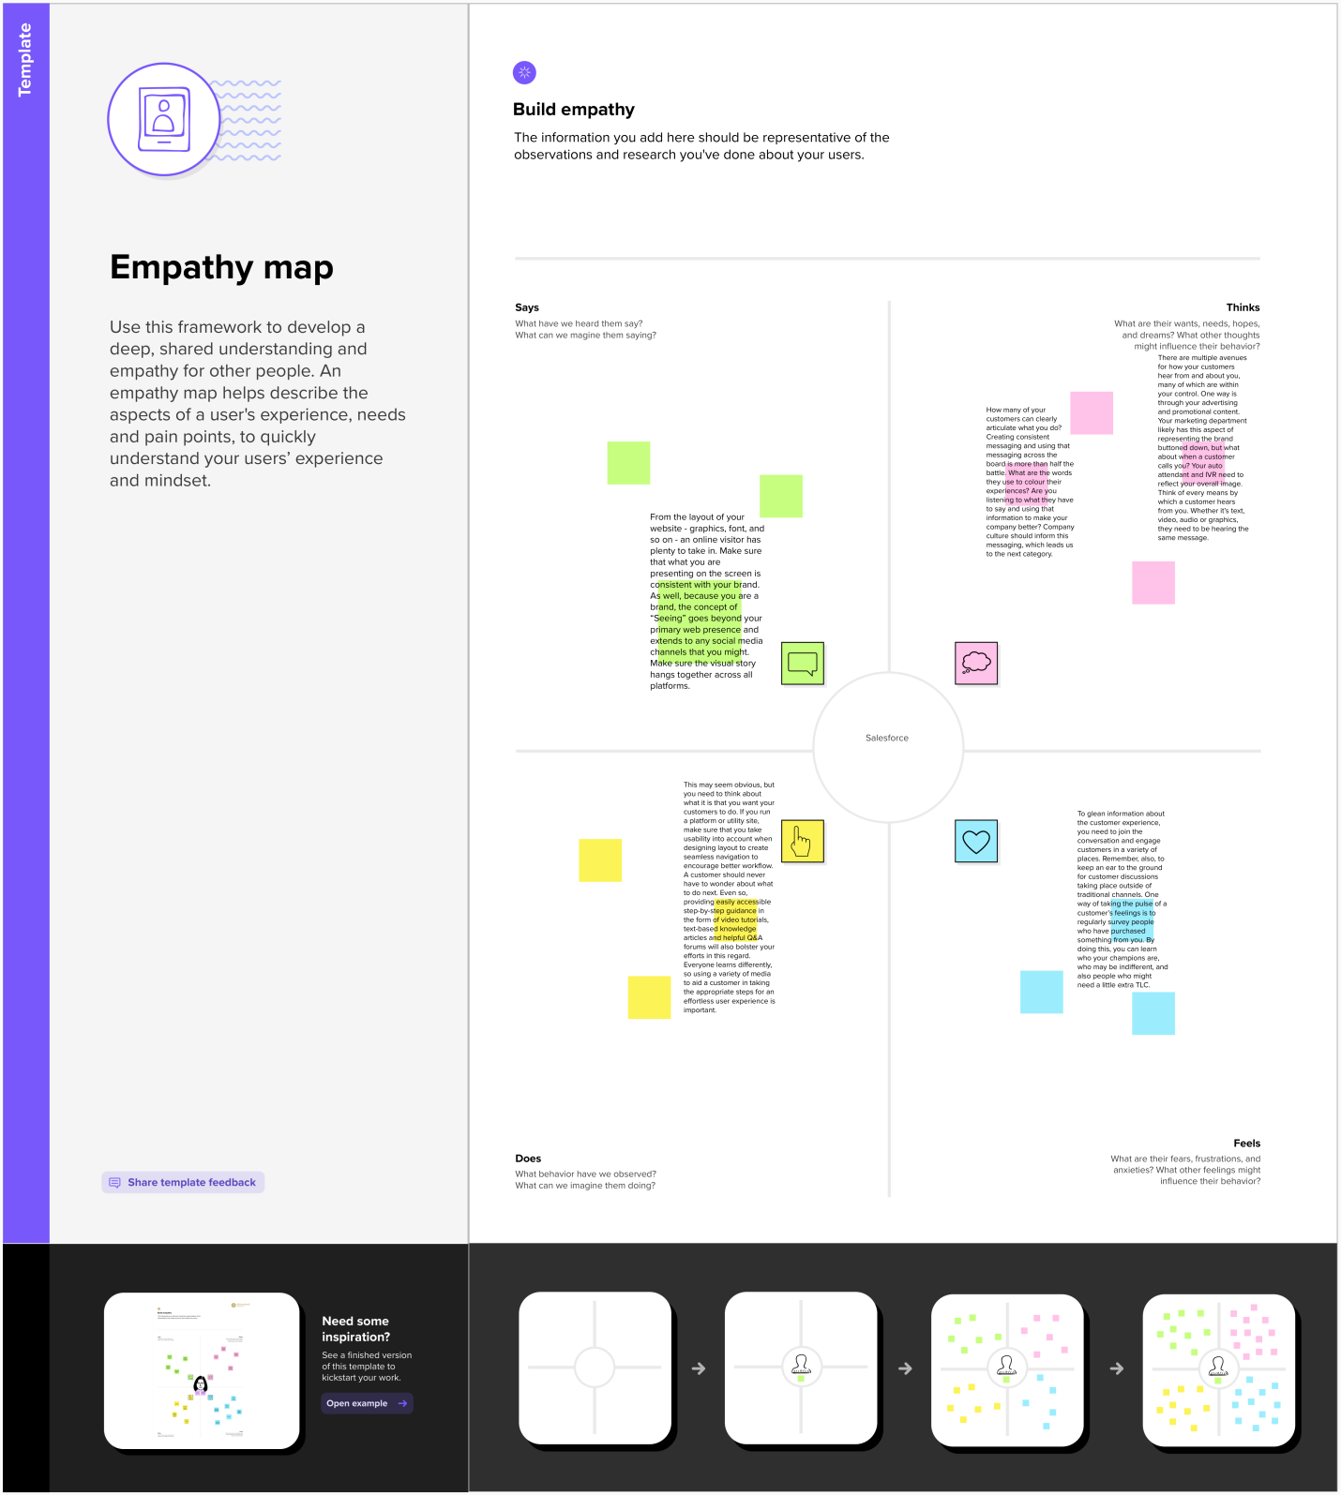

**Ideation & Brainstorming Map:-**

 It basically means is **taking all ideas out of your mind and organize those into a map**. The map looks like the picture of your brain. When one level is done and the whole picture is visual, your brain automatically starts developing those ideas, incrementing ideas to more ideas, assuming relationships between them.

Brainstorming is used to generate more ideas in a short span of time and later organizing & rating the ideas. Mind mapping is a technique used to visually organize information and shows relationships among parts of the whole.

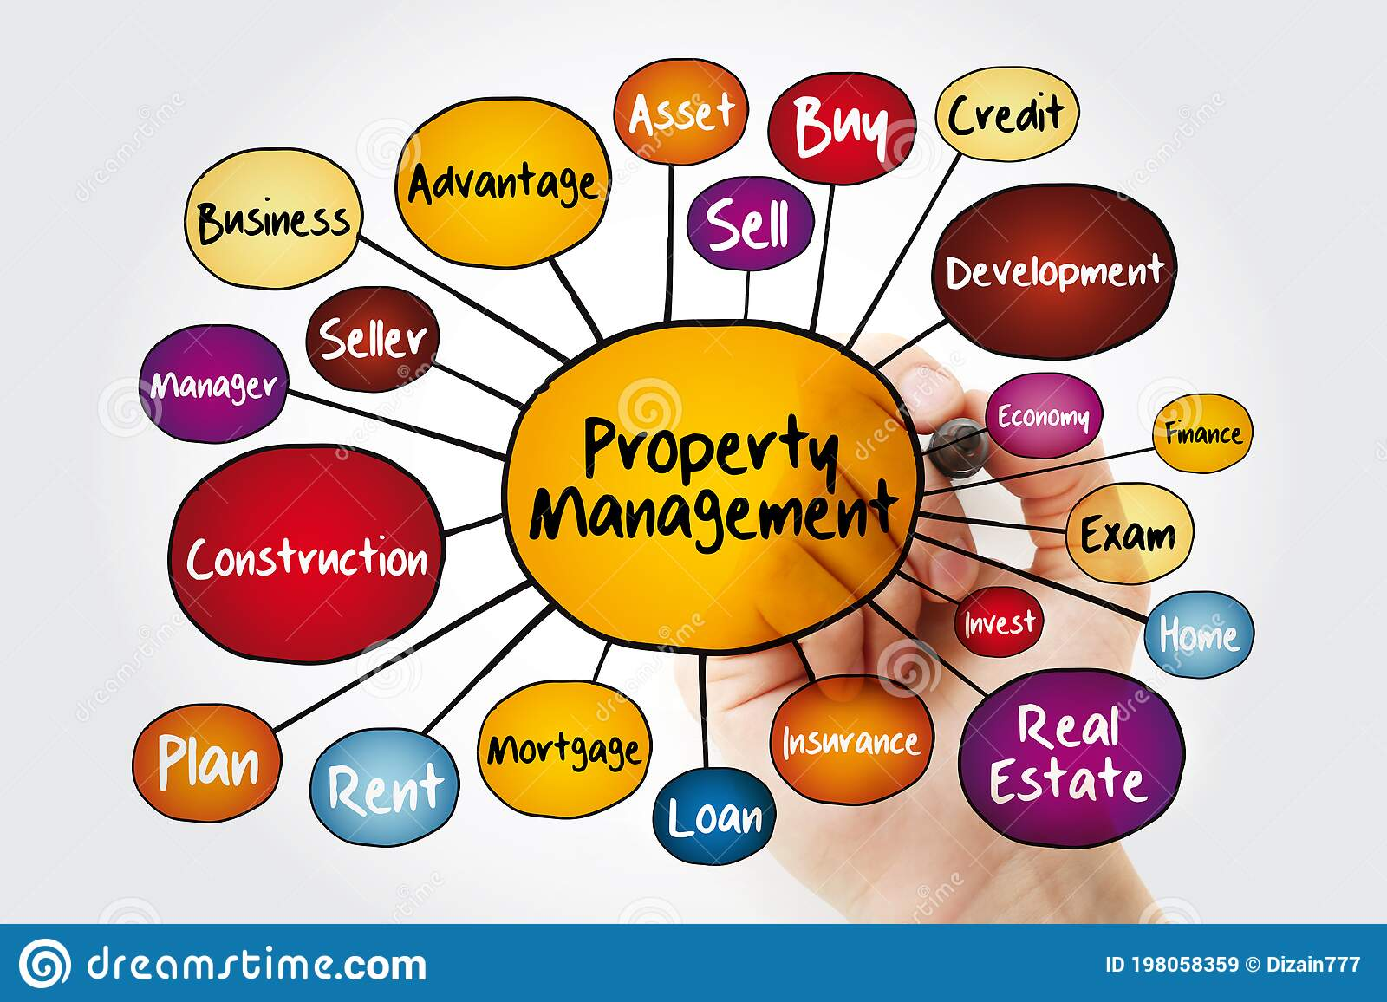

**Result**

**Data Model:-**

|  |  |  |
| --- | --- | --- |
| **Object Name** | **Fields in the Object** | |
| Field Label | Data Type |
| Saturo | [Client Name](https://governmentartsandsciencec45-dev-ed.develop.lightning.force.com/lightning/setup/ObjectManager/01I2w000003RmlM/FieldsAndRelationships/Name/view) | Text |
| [State](https://governmentartsandsciencec45-dev-ed.develop.lightning.force.com/lightning/setup/ObjectManager/01I2w000003RmlM/FieldsAndRelationships/00N2w00000Zb5Vp/view) | Picklist |
| City | Picklist |
| [Phone](https://governmentartsandsciencec45-dev-ed.develop.lightning.force.com/lightning/setup/ObjectManager/01I2w000003RmlM/FieldsAndRelationships/00N2w00000Zb5da/view) | Phone |
| [Email](https://governmentartsandsciencec45-dev-ed.develop.lightning.force.com/lightning/setup/ObjectManager/01I2w000003RmlM/FieldsAndRelationships/00N2w00000Zb5dQ/view) | Email |
| Buy | [Buyer's Name](https://governmentartsandsciencec45-dev-ed.develop.lightning.force.com/lightning/setup/ObjectManager/01I2w000003Rmlg/FieldsAndRelationships/Name/view) | Text |
| [State](https://governmentartsandsciencec45-dev-ed.develop.lightning.force.com/lightning/setup/ObjectManager/01I2w000003RmlM/FieldsAndRelationships/00N2w00000Zb5Vp/view) | Picklist |
| City | Picklist |
| [Property Type](https://governmentartsandsciencec45-dev-ed.develop.lightning.force.com/lightning/setup/ObjectManager/01I2w000003Rmlg/FieldsAndRelationships/00N2w00000Zb6FE/view) | Picklist |
| [Discount](https://governmentartsandsciencec45-dev-ed.develop.lightning.force.com/lightning/setup/ObjectManager/01I2w000003Rmlg/FieldsAndRelationships/00N2w00000Zb6Nj/view) | Percent |
| [Annual Amount To Be Paid](https://governmentartsandsciencec45-dev-ed.develop.lightning.force.com/lightning/setup/ObjectManager/01I2w000003Rmlg/FieldsAndRelationships/00N2w00000Zb6Uv/view) | Currency |
| Loan | [Client Name](https://governmentartsandsciencec45-dev-ed.develop.lightning.force.com/lightning/setup/ObjectManager/01I2w000003Rmlq/FieldsAndRelationships/Name/view) | Text |
| [Loan ID](https://governmentartsandsciencec45-dev-ed.develop.lightning.force.com/lightning/setup/ObjectManager/01I2w000003Rmlq/FieldsAndRelationships/00N2w00000Zb6il/view) | Number |
| [Interest Rate](https://governmentartsandsciencec45-dev-ed.develop.lightning.force.com/lightning/setup/ObjectManager/01I2w000003Rmlq/FieldsAndRelationships/00N2w00000Zb6nD/view) | Currency |
| [Term](https://governmentartsandsciencec45-dev-ed.develop.lightning.force.com/lightning/setup/ObjectManager/01I2w000003Rmlq/FieldsAndRelationships/00N2w00000Zb6o6/view) | Number |
| [Annual Loan](https://governmentartsandsciencec45-dev-ed.develop.lightning.force.com/lightning/setup/ObjectManager/01I2w000003Rmlq/FieldsAndRelationships/00N2w00000Zb6oG/view) | Number |
| [Total Loan Instalments](https://governmentartsandsciencec45-dev-ed.develop.lightning.force.com/lightning/setup/ObjectManager/01I2w000003Rmlq/FieldsAndRelationships/00N2w00000Zb6r5/view) | Number |
| [Loan Repayment](https://governmentartsandsciencec45-dev-ed.develop.lightning.force.com/lightning/setup/ObjectManager/01I2w000003Rmlq/FieldsAndRelationships/00N2w00000Zb6rU/view) | Number |
| [Loan Amount](https://governmentartsandsciencec45-dev-ed.develop.lightning.force.com/lightning/setup/ObjectManager/01I2w000003Rmlq/FieldsAndRelationships/00N2w00000Zb6wk/view) | Formula (Currency) |
| Rent | [Name](https://governmentartsandsciencec45-dev-ed.develop.lightning.force.com/lightning/setup/ObjectManager/01I2w000003Rmll/FieldsAndRelationships/Name/view) | Text |
| [Rental City](https://governmentartsandsciencec45-dev-ed.develop.lightning.force.com/lightning/setup/ObjectManager/01I2w000003Rmll/FieldsAndRelationships/00N2w00000Zb6a6/view) | Text |
| [BHK type](https://governmentartsandsciencec45-dev-ed.develop.lightning.force.com/lightning/setup/ObjectManager/01I2w000003Rmll/FieldsAndRelationships/00N2w00000Zb6eO/view) | Picklist |

**Activities & Screenshot:-**

**1-Developing Account**

**Activity1:**

**Creating Developer Account**

Creating a developer org in salesforce.

1. Go to developers.salesforce.com/

2. Click on sign up.

3. On the sign up form, enter the following details :

a. First name & Last name

b. Email

c. Role : Developer

d. Company : College Name

e. County : India

f. Postal Code : pin code

g. Username : should be a combination of your name and company

This need not be an actual email id, you can give anything in the format : [username@organization.com](mailto:username@organization.com)

Click on sign up after filling these

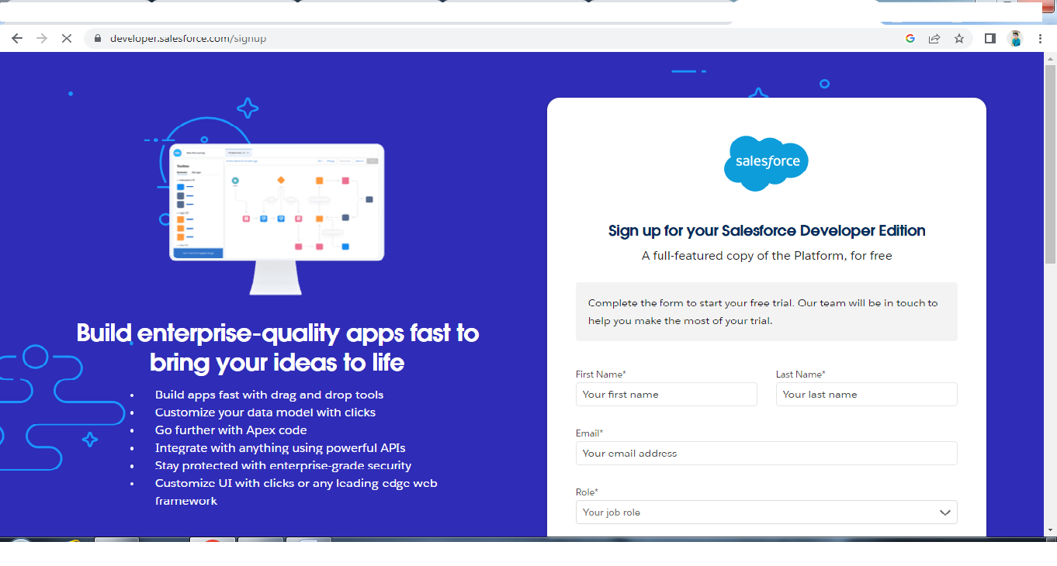

**Activity 2-**

**Account Activation**

1. Go to the inbox of the email that you used while signing up.
2. Click on the verify account to activate your account. The email may take 5-10mins, as 2.
3. Login To Your Salesforce Account

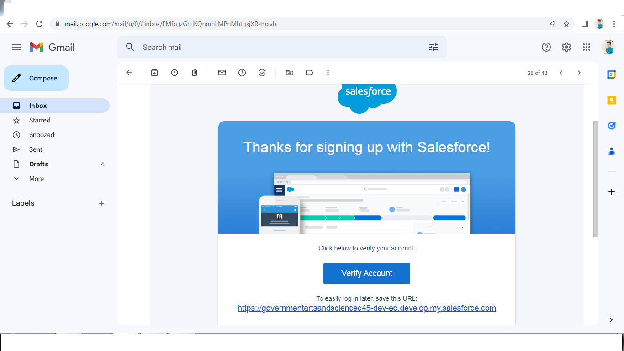

**2- Object**

What Is Object? Salesforce objects are database tables that permit you to store data that is specific to an organization. What are the types of Salesforce objects

**Salesforce objects are of two types:**

● Standard Objects: Standard objects are the kind of objects that are provided by salesforce.com such as users, contracts, reports, dashboards, etc.

● Custom Objects: Custom objects are those objects that are created by users. They supply information that is unique and essential to their organization. They are the heart of any application and provide a structure for sharing data.

**Activity1:**

**Objects**

**To Navigate to Setup page:**

1. Click on gear icon → click setup.

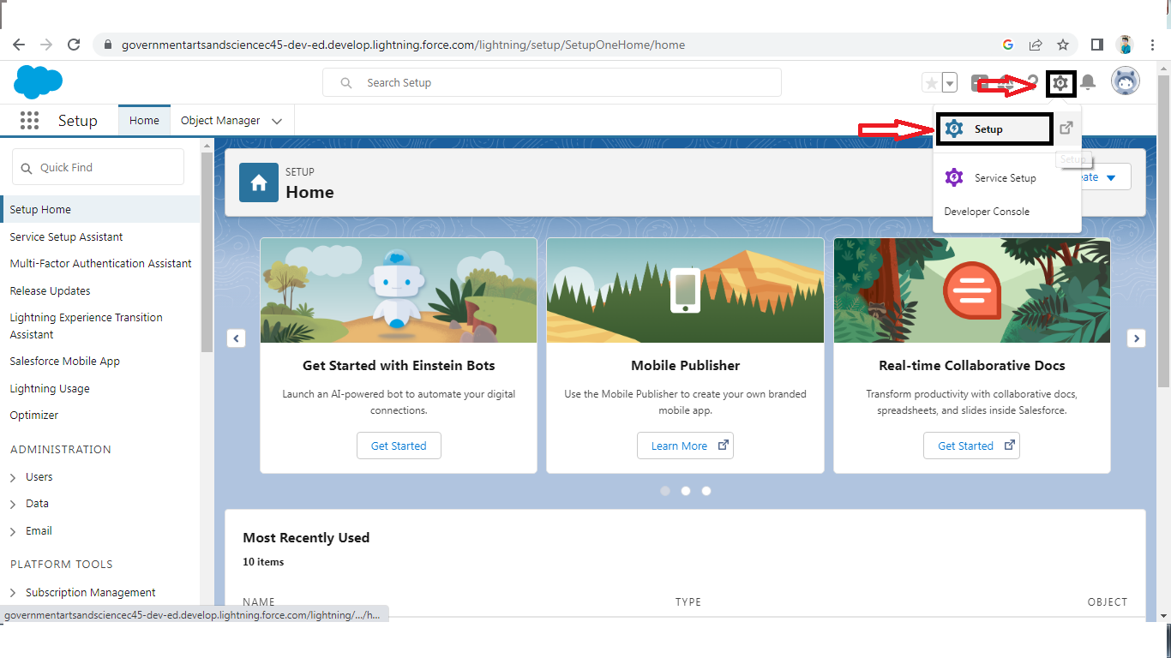

**To create an object:**

1. From the setup page → Click on Object Manager → Click on Create → Click on Custom Object.

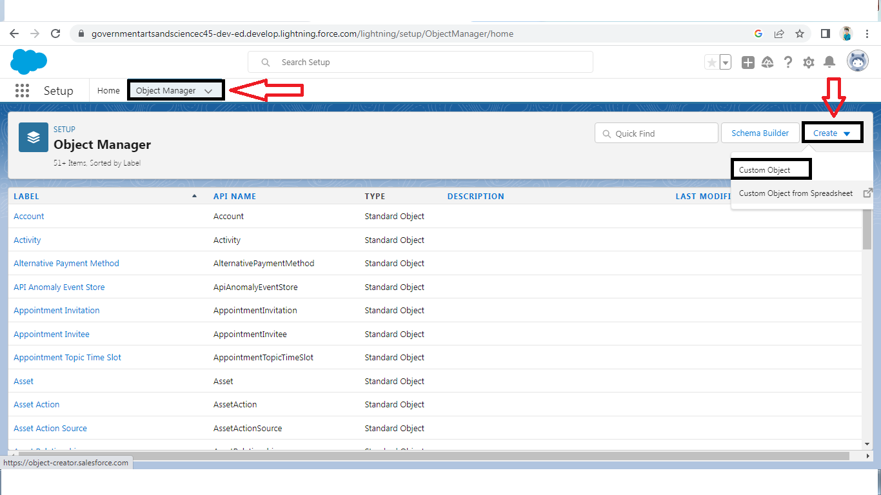

On Custom object defining page:

1. Enter the label name, plural label name, click on Allow reports, Allow search → Save

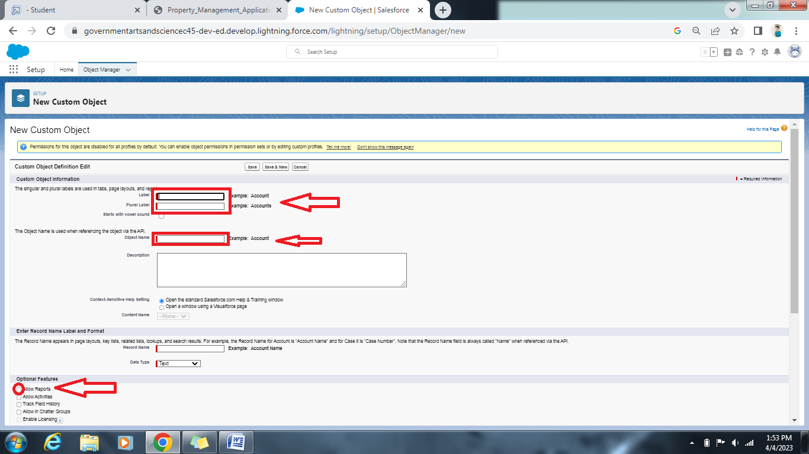

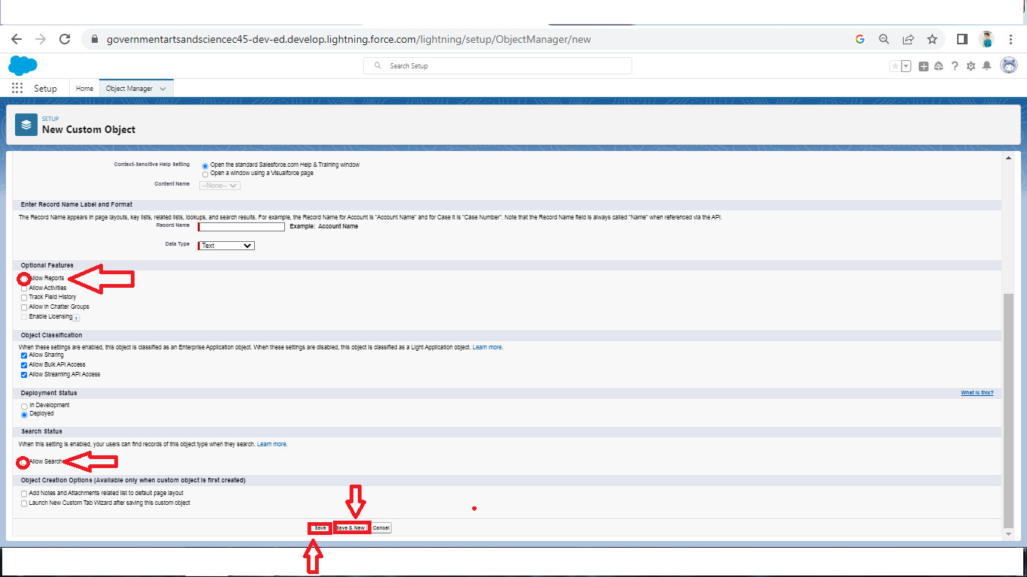

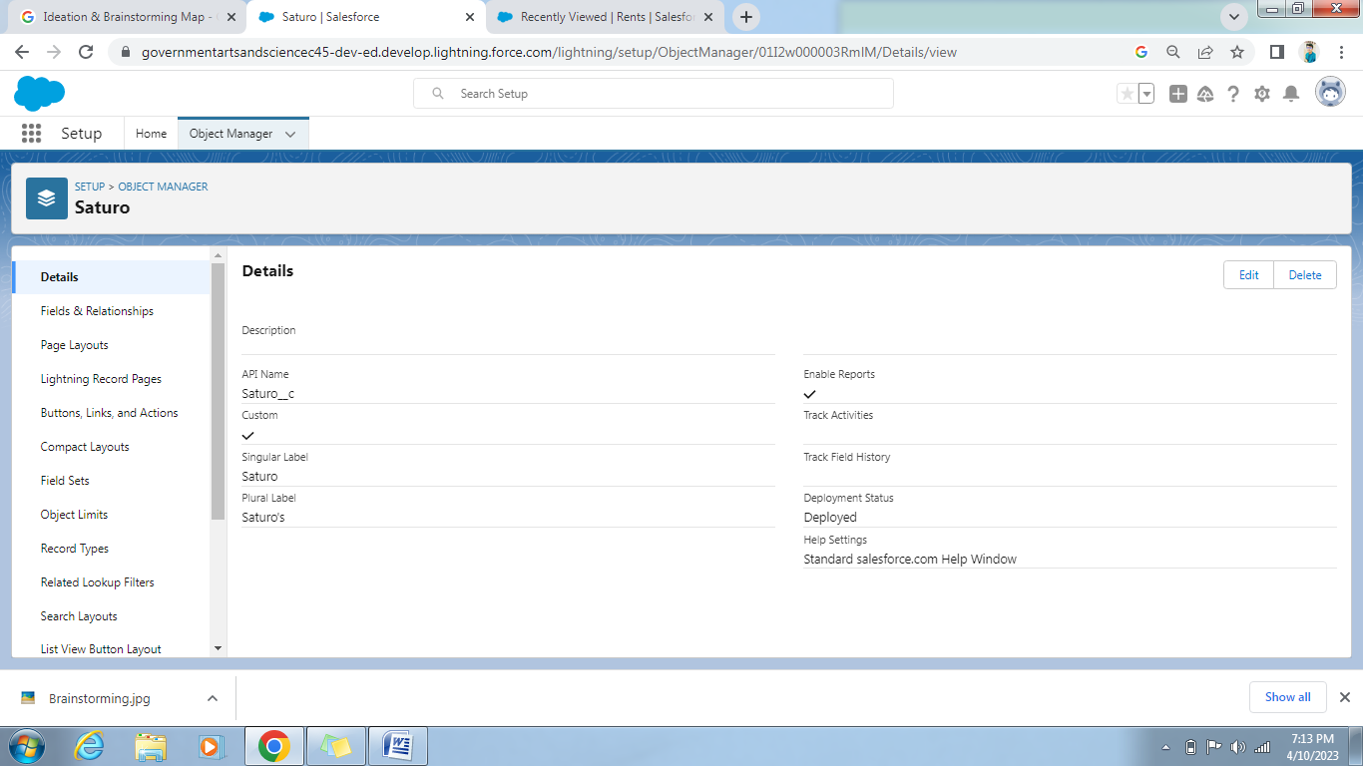

**Activity2:**

**Create Object Buy**

1. To create an object:

2. From the setup page → Click on Object Manager → Click on Create → Click on Custom Object.

3. Enter the label name→Buy

4. plural label name→ Buyers

5. click on Allow reports,

6. Allow search → Save

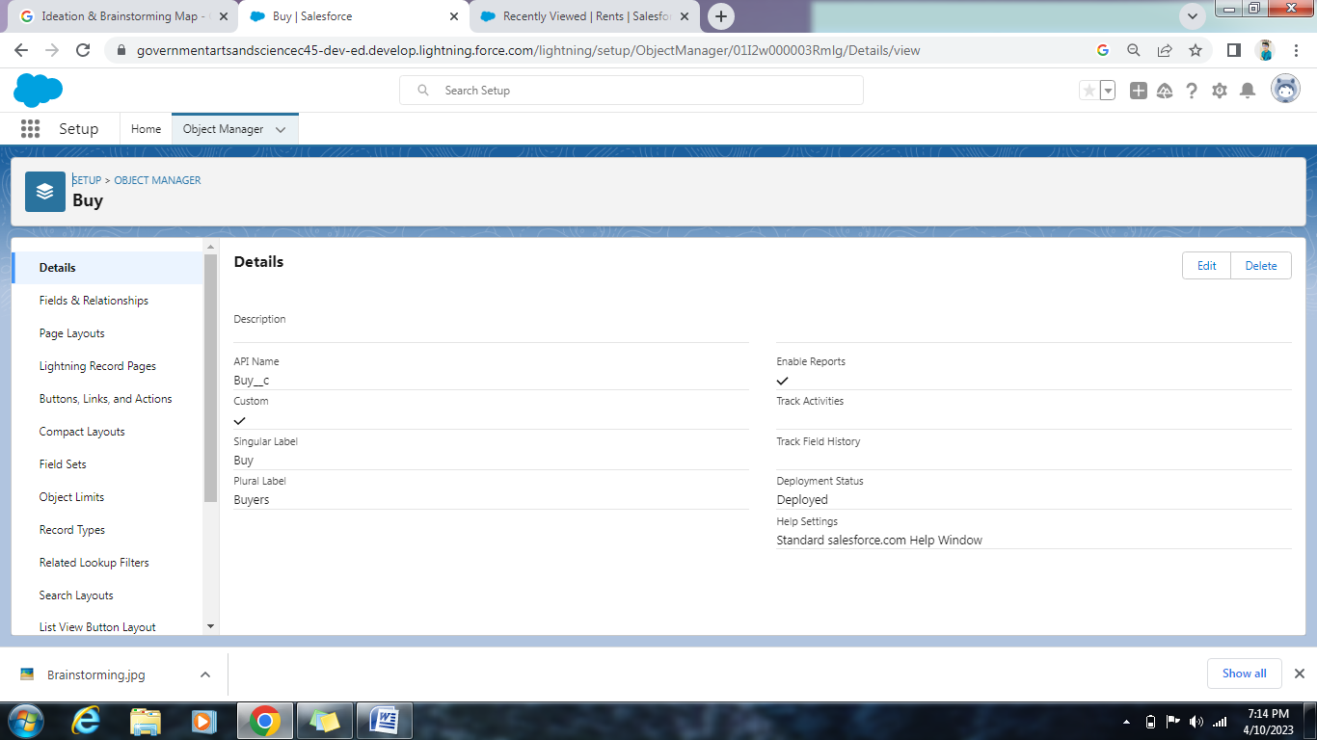

**Activity3:**

**Create Object Rent**

1. To create an object:

2. From the setup page → Click on Object Manager → Click on Create → Click on Custom Object.

3. Enter the label name→Rent

4. plural label name→ Rents

5. click on Allow reports,

6. Allow search → Save

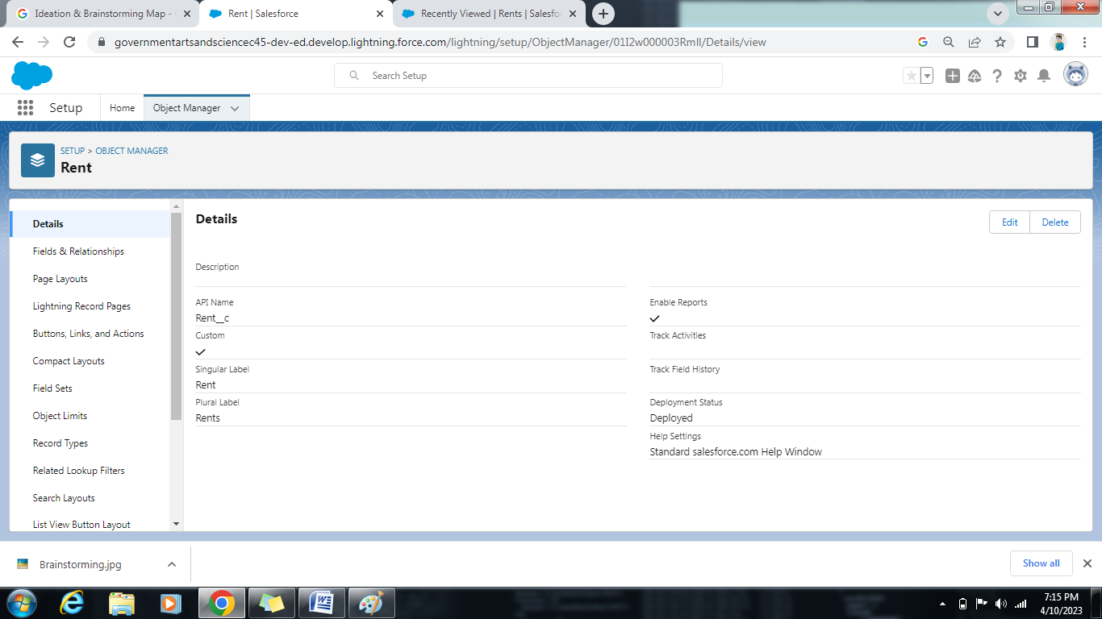

**Activity4:**

**Create Object Loan**

1. To create an object:

2. From the setup page → Click on Object Manager → Click on Create → Click on Custom Object.

3. Enter the label name→Loan

4. plural label name→ Loans

5. click on Allow reports,

6.Allow search → Save

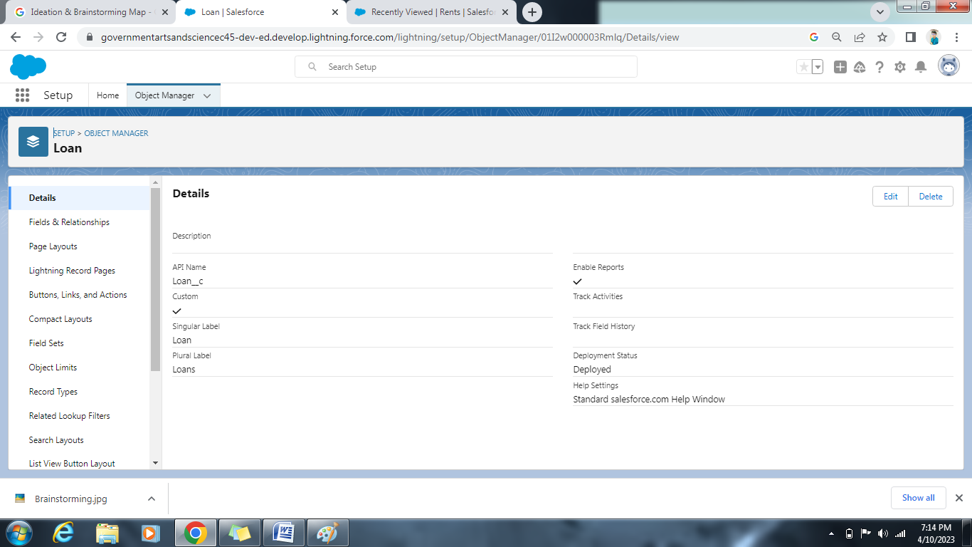

**3- Tab**

**What is Tab?**

A tab is like a user interface that is used to build records for objects and to view the records in the objects.

**Types of Tab**

● Custom object tab

● Web tab

● Visualforce tab

**Activity 1:**

**Create the Lightning Tab**

To create a Tab:(Saturo)

1. Go to setup page → type Tabs in Quick Find bar → click on tabs → New (under custom object tab)

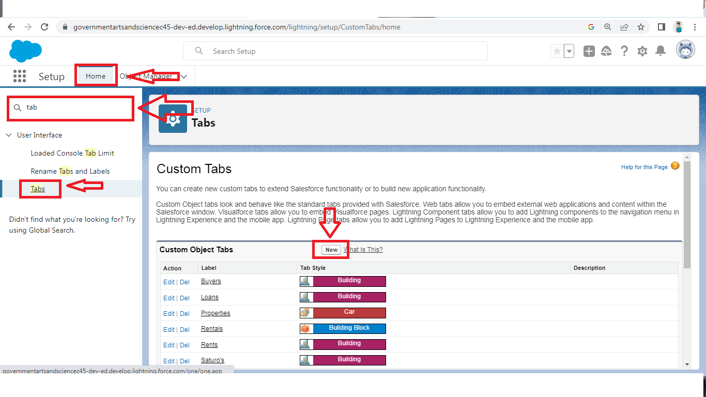

1. Select Object(Saturo) → Select the tab style → Next (Add to profiles page) keep it as default → Next (Add to Custom App) keep it as default → Save.

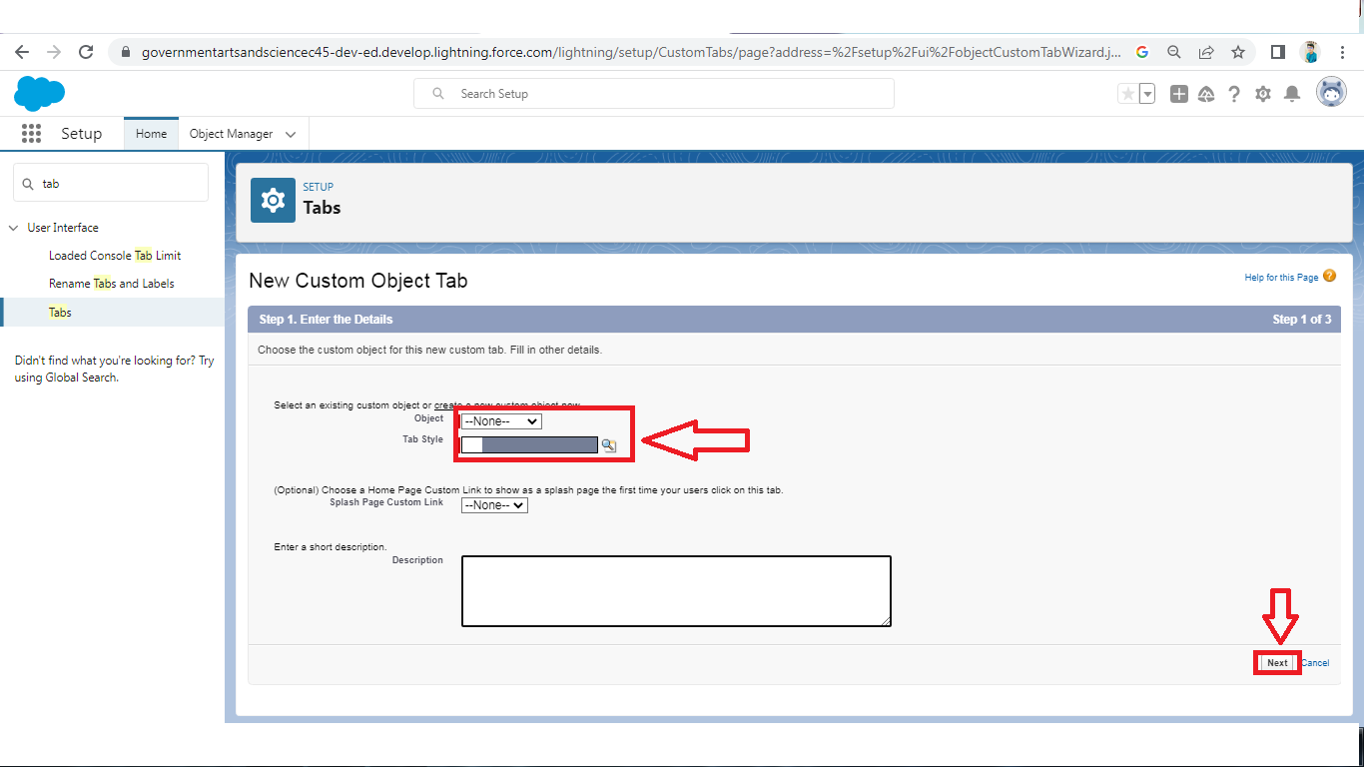

**Activity 2:**

To create a Tab:(Buy)

1. Go to setup page → type Tabs in Quick Find bar → click on tabs → New (under custom object tab)

2. Select Object(Buy) → Select the tab style → Next (Add to profiles page) keep it as default → Next (Add to Custom App) keep it as default → Save.

**Activity 3:**

To create a Tab:(Rent)

1. Go to setup page → type Tabs in Quick Find bar → click on tabs → New (under custom object tab)

2. Select Object(Rent) → Select the tab style → Next (Add to profiles page) keep it as default → Next (Add to Custom App) keep it as default → Save

**Activity4:**

To create a Tab:(Loan)

1. Go to setup page → type Tabs in Quick Find bar → click on tabs → New (under custom object tab)

2. Select Object(Buy) → Select the tab style → Next (Add to profiles page) keep it as default → Next (Add to Custom App) keep it as default → Save

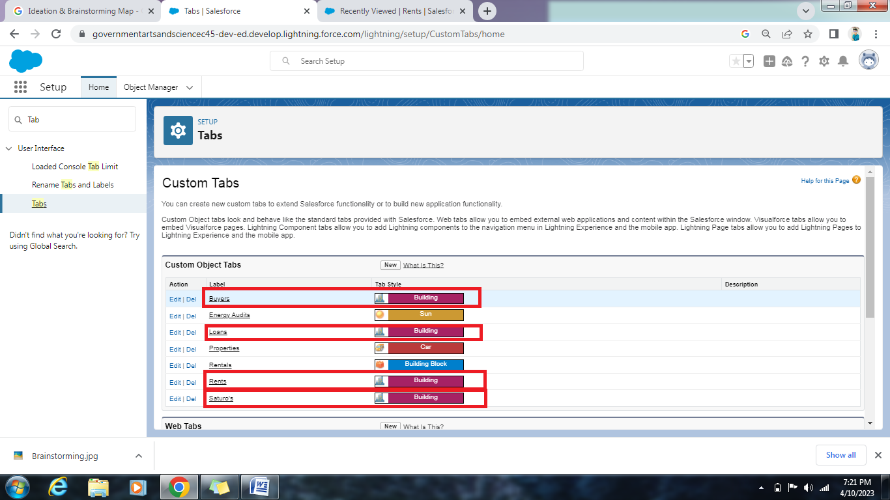

**4- The Lightning App:**

An app is a collection of items that work together to serve a particular function. In Lightning Experience, Lightning apps give your users access to sets of objects, tabs, and other items all in one convenient bundle in the navigation bar.

Lightning apps let you brand your apps with a custom color and logo. You can even include a utility bar and Lightning page tabs in your Lightning app. Members of your org can work more efficiently by easily switching between apps.

**Activity1:**

**Create the Lightning App**

1. Go to setup page → search “app manager” in quick find → select “app manager” → click on New lightning App.

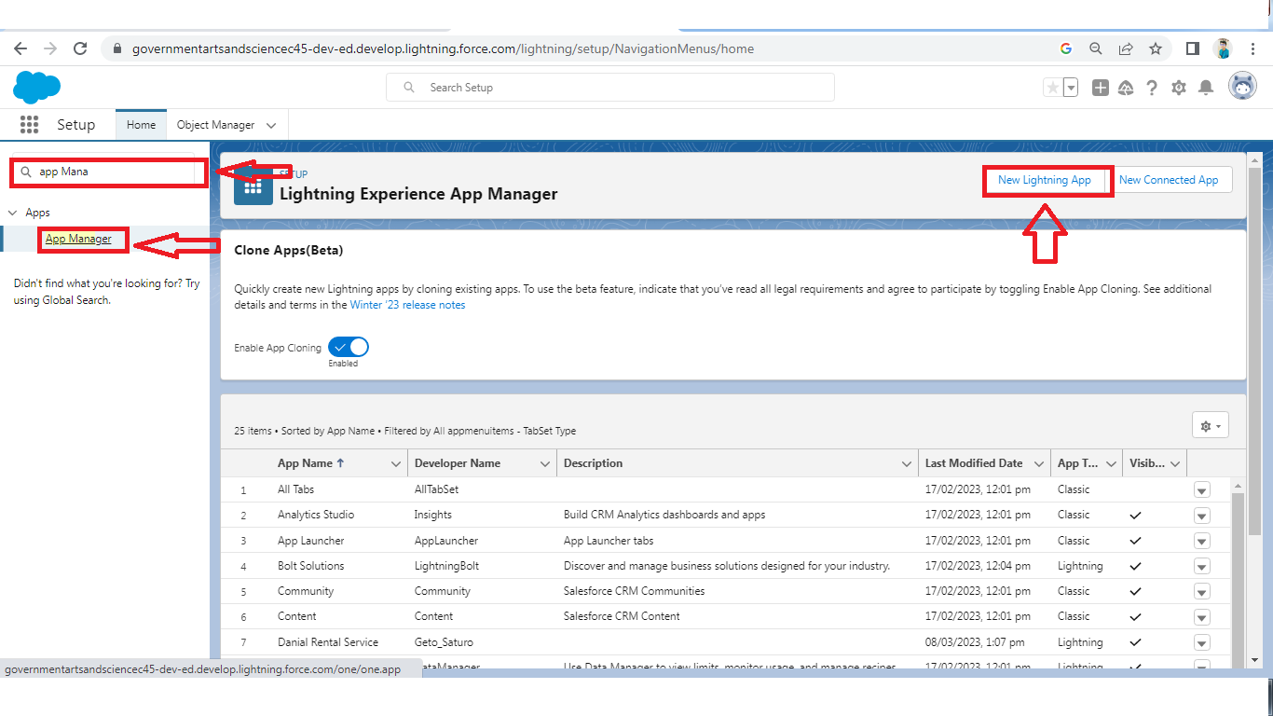

2. Fill the app name as an Property Management in app details and branding →Next → (App option page) keep it as default → Next

3. (Utility Items) keep it as default → Next → (Add Navigation Items)(add tabs Saturo, Buy, Rent, Loan) → Next → (Add User Profile) Add System Administrator, Salesforce platform user, Standard User → Next.

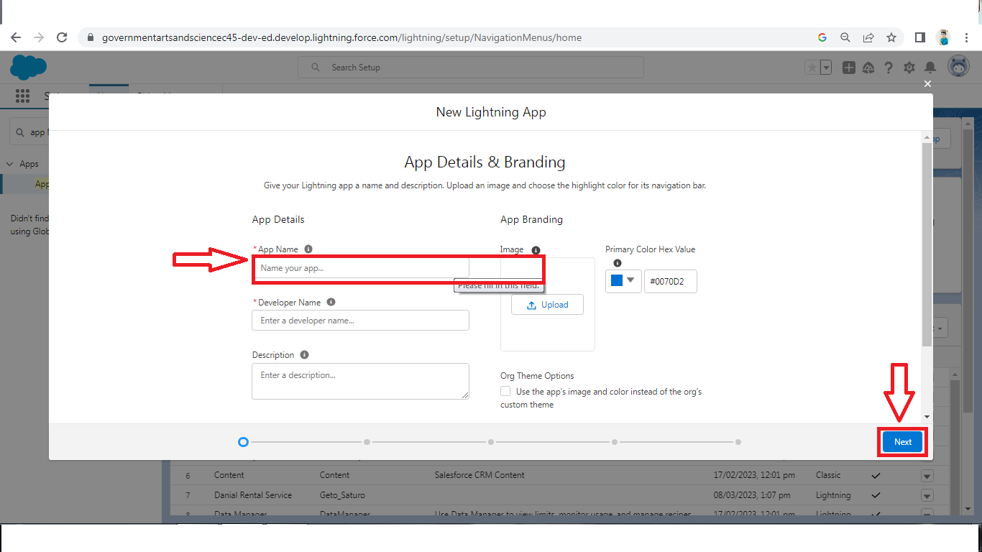

4. To Add Navigation Items:

Select the items from the search bar and move it using the arrow button → Next.

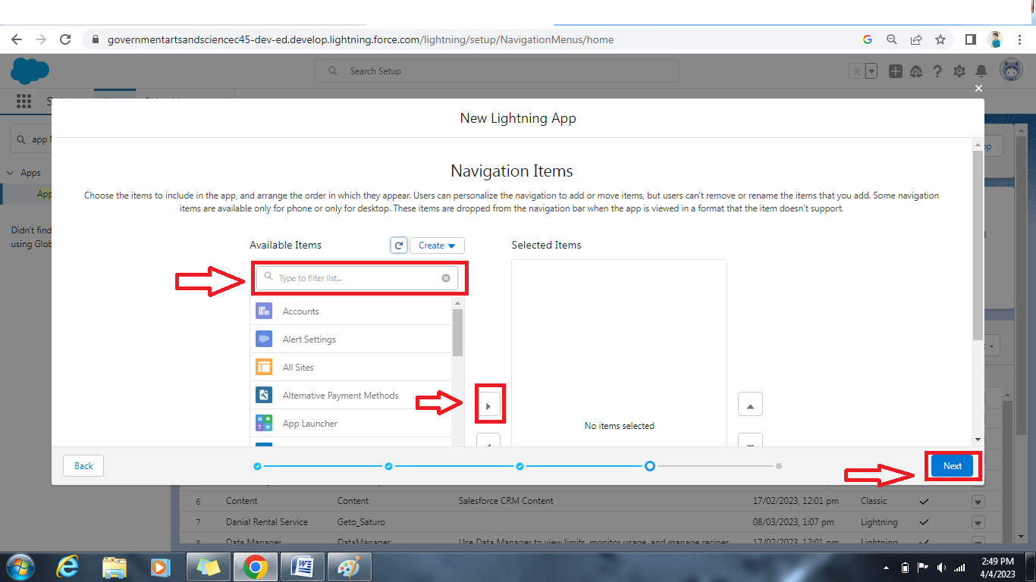

5. To Add User Profiles: Search profiles in search bar → click on the arrow button → save & finish

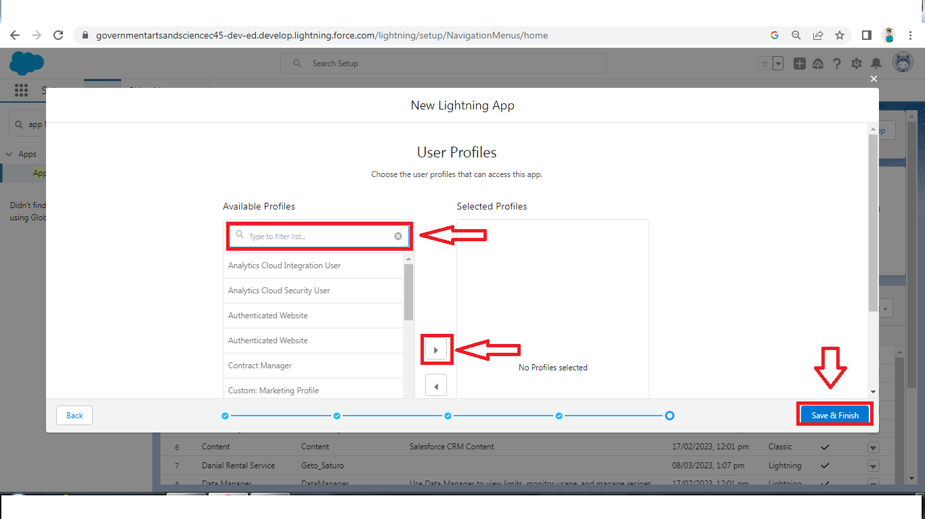

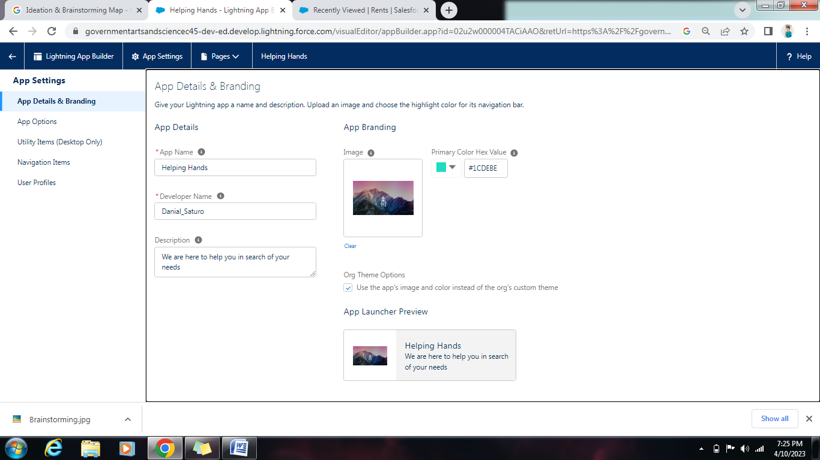

**5-Fields**

When we talk about Salesforce, Fields represent the data stored in the columns of a relational database. It can also hold any valuable information that you require for a specific object. Hence, the overall searching, deletion, and editing of the records become simpler and quicker.

**Types of Fields**

● Standard Fields

● Custom Fields

**Standard Fields:**

As the name suggests, the Standard Fields are the predefined fields in Salesforce that perform a standard task. The main point is that you can’t simply delete a Standard Field until it is a non-required standard field. Otherwise, users have the option to delete them at any point from the application freely. Moreover, we have some fields that you will find common in every Salesforce application. They are,

● Created By

● Owner

● Last Modified

● Field Made During object Creation

**Custom Fields:**

On the other side of the coin, Custom Fields are highly flexible, and users can change them according to requirements. Moreover, each organizer or company can use them if necessary. It means you need not always include them in the records, unlike Standard fields. Hence, the final decision depends on the user, and he can add/remove Custom Fields of any given form.

**Activity 1:**

Create the Saturo Field

1. Go to setup → click on Object Manager → type object name in search bar → click on the object

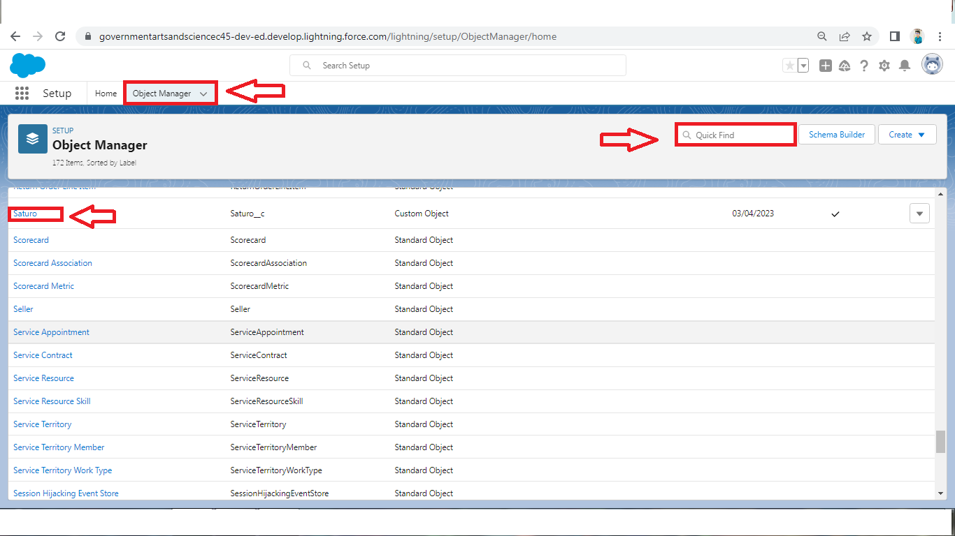

1. Now click on “Fields & Relationships ” → New.

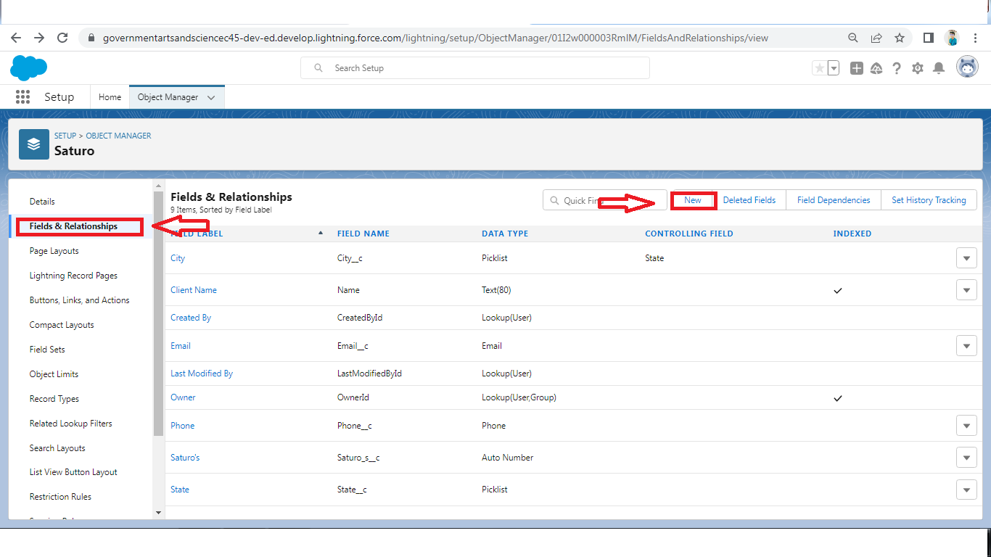

1. Fill the field label name Lead → Next → Next → Save.

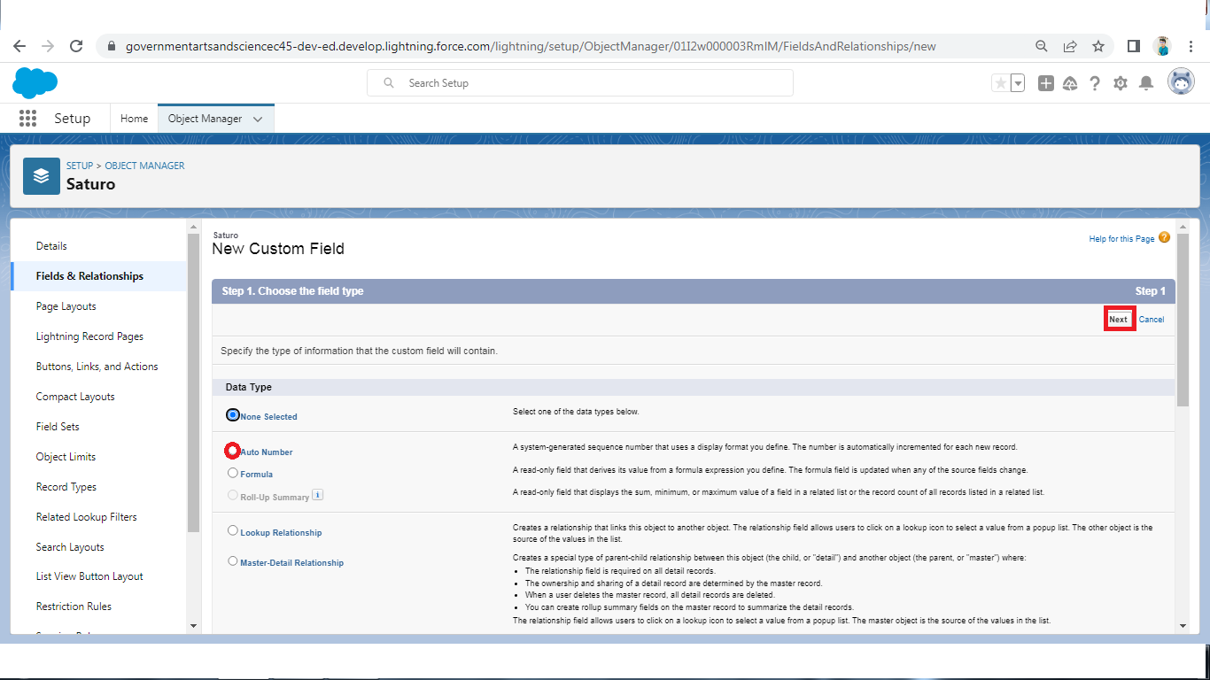

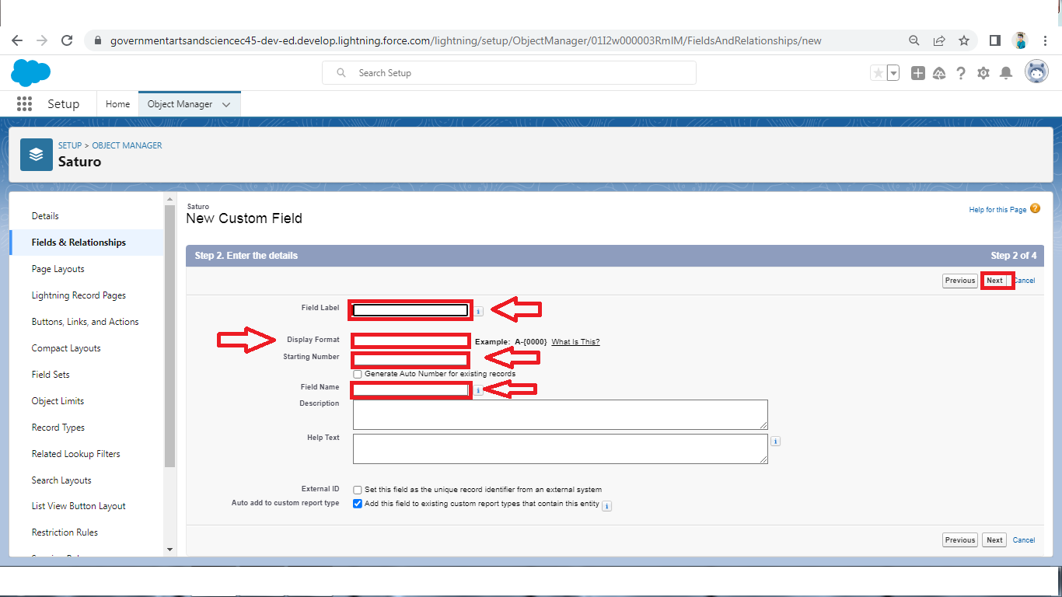

**Create the remaining Fields:**

Follow the Above Steps to create the Field just change the Labels for Below Fields

**Saturo**: (AutoNumber Created Field while creating Object) →L-{0000}

**State:** Create the Picklist Field (Maharashtra, Gujarat, Rajasthan)(Field Dependency)

**City:** Create the Picklist(Mumbai, Pune, Nashik)(Field Dependency)

**Email:** Create the Email Select the Data Type As Email (Email)

**Phone:** Select the Field Data type as (Phone)

In the Fields and Relationship go to the Field Dependencies

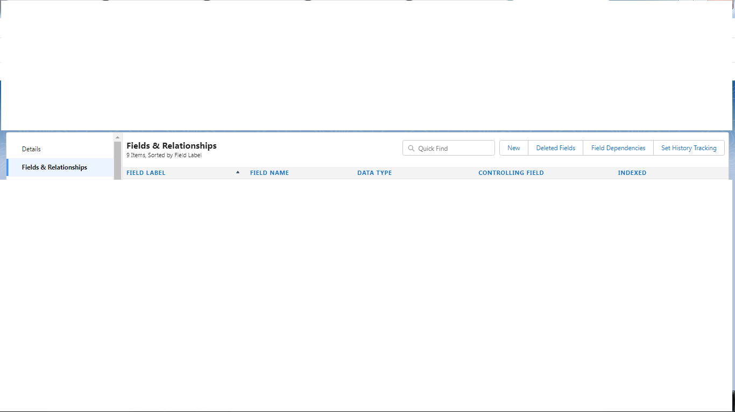

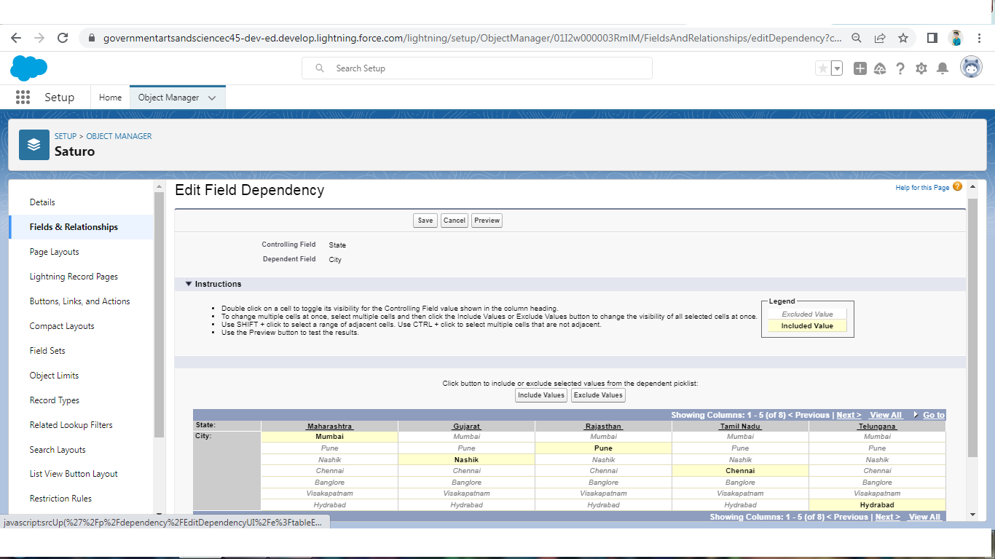

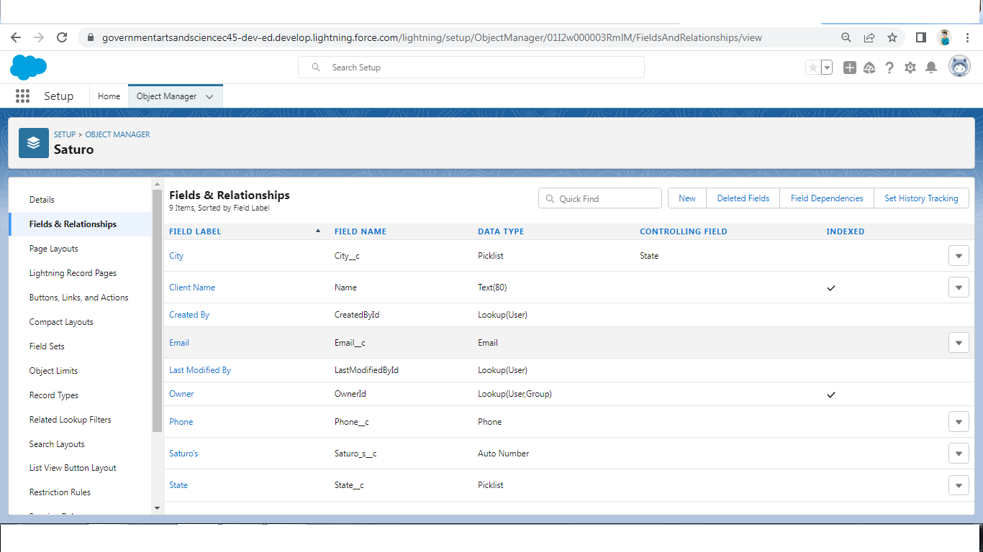

**Activity2:**

For Object Buy

1. Create Field for Buy

2. **Create Property Type:** (Picklist) (Residential, Commercial, Industrial)

3. **Discount:** (Percentage As the Field Data Type)

4. **State:** Create the Picklist Field (Maharashtra, Gujarat, Rajasthan)(Field Dependency)

5. **City:** (Take Any City for Field Dependency)

6. Annual Amount To Be Paid

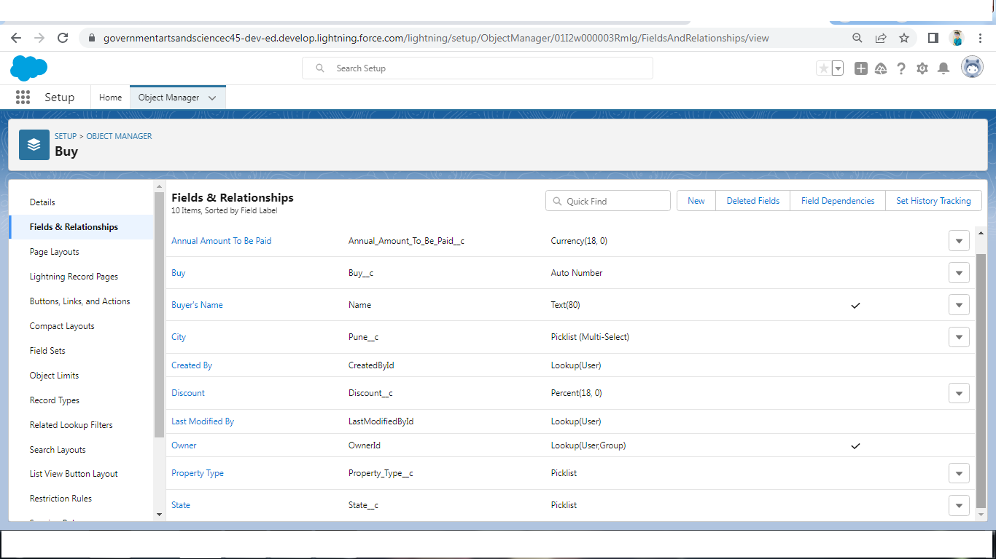

**Activity3:**

Create Field for Rent

1. **Rent:** (Auto Number while Creating the object)→ R-{0000}

2. **Rental City:** Select the Text as the Field Data Name(Any City)

3. **BHK type:** (Picklist) (1BHK, 2BHK,3BHK)

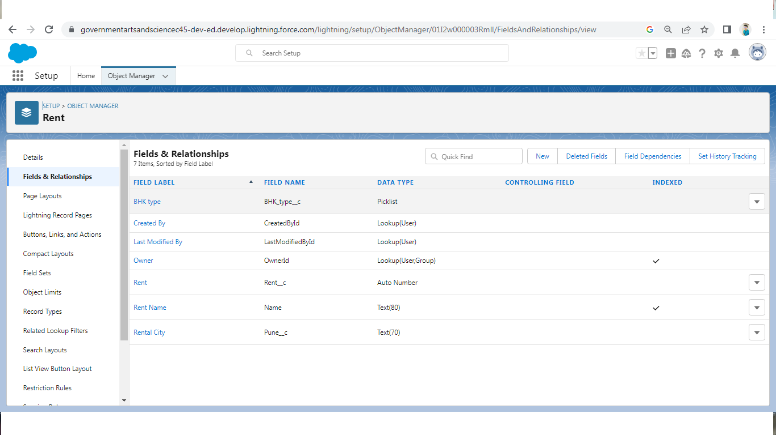

**Activity4:**

Create Field for Loan

1. **Loan Id:** Auto generated Field Take it as Autonumber LN-{0000}

2. **Interest Rate:** (Select the Field Data Type As Currency)

3. **Term:** (Select the Field Data type as Number)

4. Annual Loan Field create the Number as the field data type

5. **Total Loan Instalments:** ( Field create the Number as the field data type)

6. **Loan Repayment** ( Field create the Number as the field data type)

7. **Loan Amoun** ( Select the Field data type as Formula)

8. For the Loan Object→ Go to the fields and Relationship and select the formula in field data type.

In Formula option select Advanced Formula and write the following formula (Loan_Repayment__c * (((1+( Interest_rate__c /52))^ Term__c) -1))/(( Interest_rate__c /52)*((1+( Interest_rate__c /52))^ Term__c))

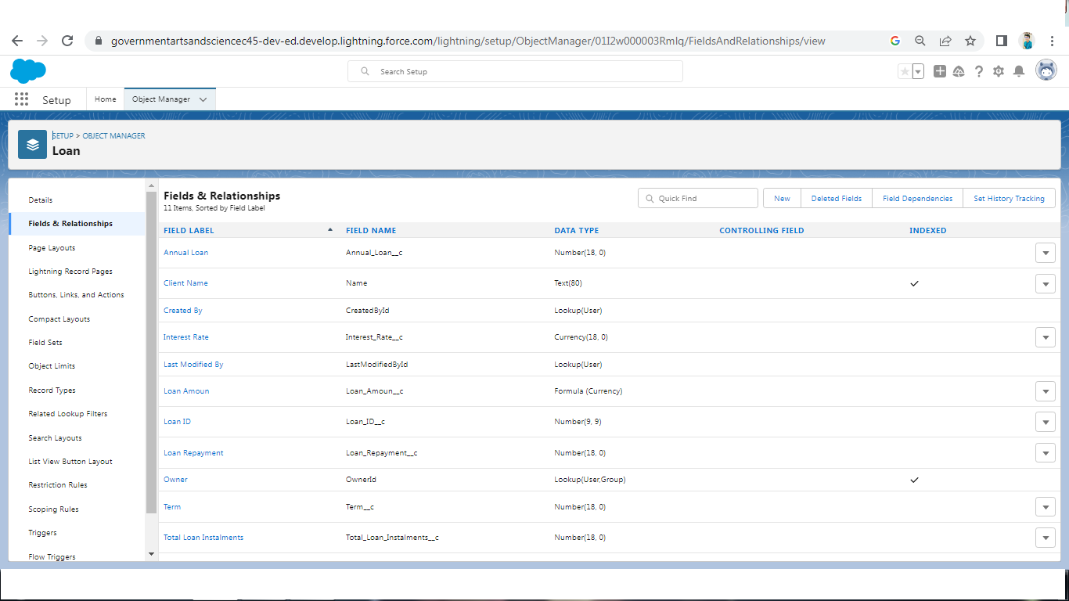

**6- Profile**

● A profile is a group/collection of settings and permissions that define what a user can do in salesforce.

● Profile controls “Object permissions, Field permissions, User permissions, Tab settings, App settings,

Apex class access, Visualforce page access, Page layouts, Record Types, Login hours & Login IP

ranges.

● You can define profiles by the user's job function. For example System Administrator, Developer,

Sales Representative.

**Types of profiles in salesforce**

1.Standard Profiles:

● By default salesforce provide below standard profiles.

● We cannot deleted standard ones

● .Each of these standard one includes a default set of permissions for all of the standard objects available on the platform.

2.Custom Profiles:

● Custom ones defined by us.

● They can be deleted if there are no users assigned with that particular one.

**Activity 1:**

To create a new profile:

1. Go to setup → type profiles in quick find box → click on profiles → clone the desired profile (standard user is preferable) → enter profile name → save

2. Enter a Profile Name

3. Click on the new created profile

4. While still on the profile page, then click Edit

5. Scroll down to Custom Object Permissions and Give view all access permissions and assign to the

parent profile

6. Sales Manager →Standard user Profile , Marketing Executive1 and Executive2→Standard Platform

User,Marketing Manager→Standard Platform User For.

**Activity 2:**

Create Marketing

1. Then In The Profile Level Give Read and Create Access to Marketing Executive and Read, Create,

Edit, Delete for the Marketing manager.

2. Marketing Manager Should Have Access to Marketing Executive.

**Activity3-Sales:**

1. In the Profile Level Sales Manager is Having Create, Edit, Delete.

2. For Sales Rep1→ Read, Create, Edit.

3. For Sales Rep2→Read, Create, Edit.

4. For Sales Rep3→ Read only.

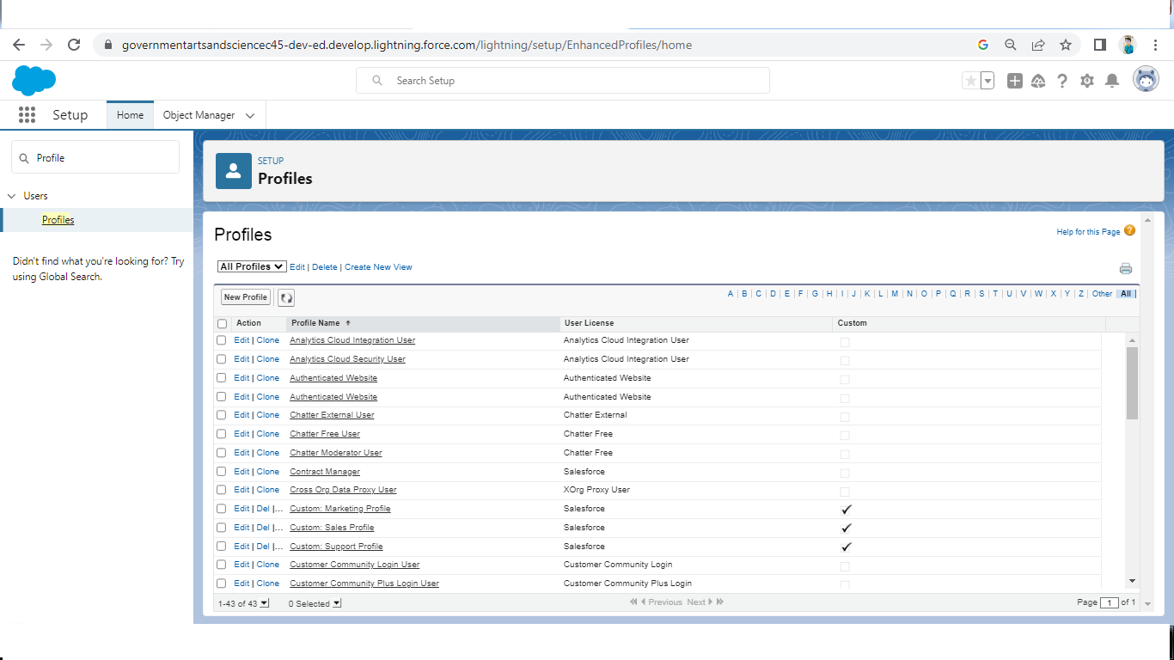

**7-New User**

● A user is anyone who logs in to Salesforce. Users are employees at your company, such as sales reps,

managers, and IT specialists, who need access to the company's records.

● Every user in Salesforce has a user account. The user account identifies the user, and the user account

settings determine what features and records the user can access.

**Activity 1:**

Create User

1. Go to setup → type users in quick find box → select users → click New user.

2. Fill in the fields (first name, last name, alias, email id, username, nick name, role, user license,

profiles) → save.

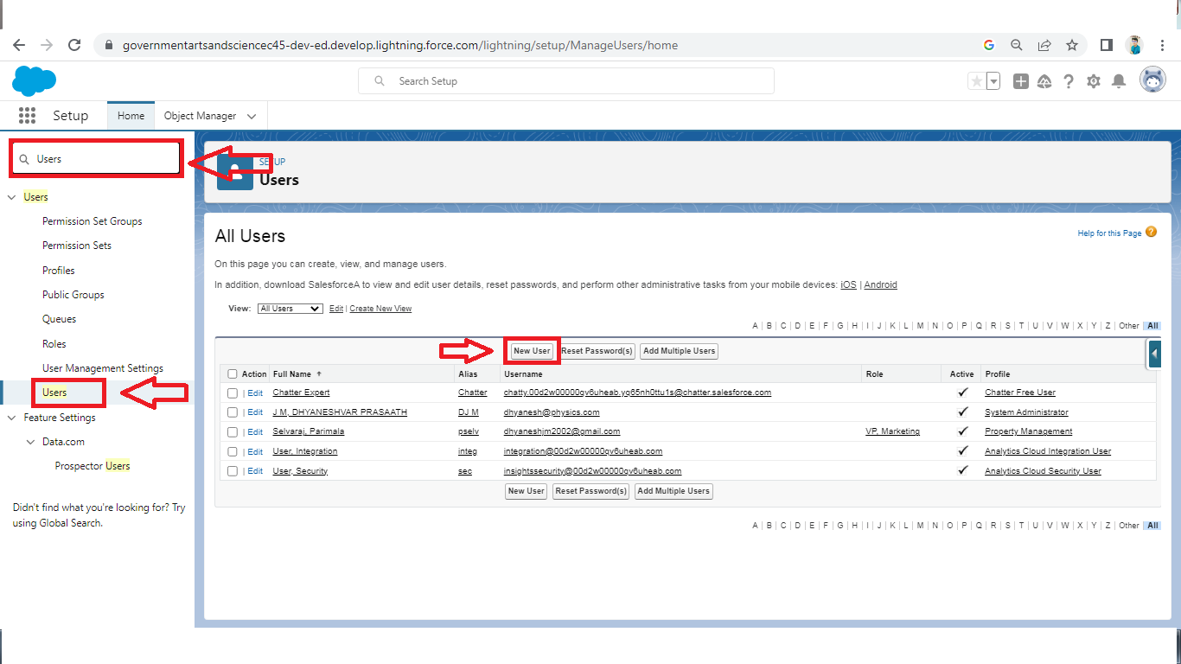

**8-Permission Set**

A permission set is a collection of settings and permissions that give users access to various tools and functions. Permission sets extend users' functional access without changing their profiles. Users can have only one profile but, depending on the Salesforce edition, they can have multiple permission sets.

Activity 1:

Create the Permission Sets

1. Go to setup → type “permission sets” in quick search → select permission sets → New.
2. Enter the label name → save.
3. After saving the permission click on the Manage assignment
4. Now click on the Add Assignment
5. Now select the users and click on save
6. Go to permission set and add the access For Sales Rep3 give Access with Create permission for the User

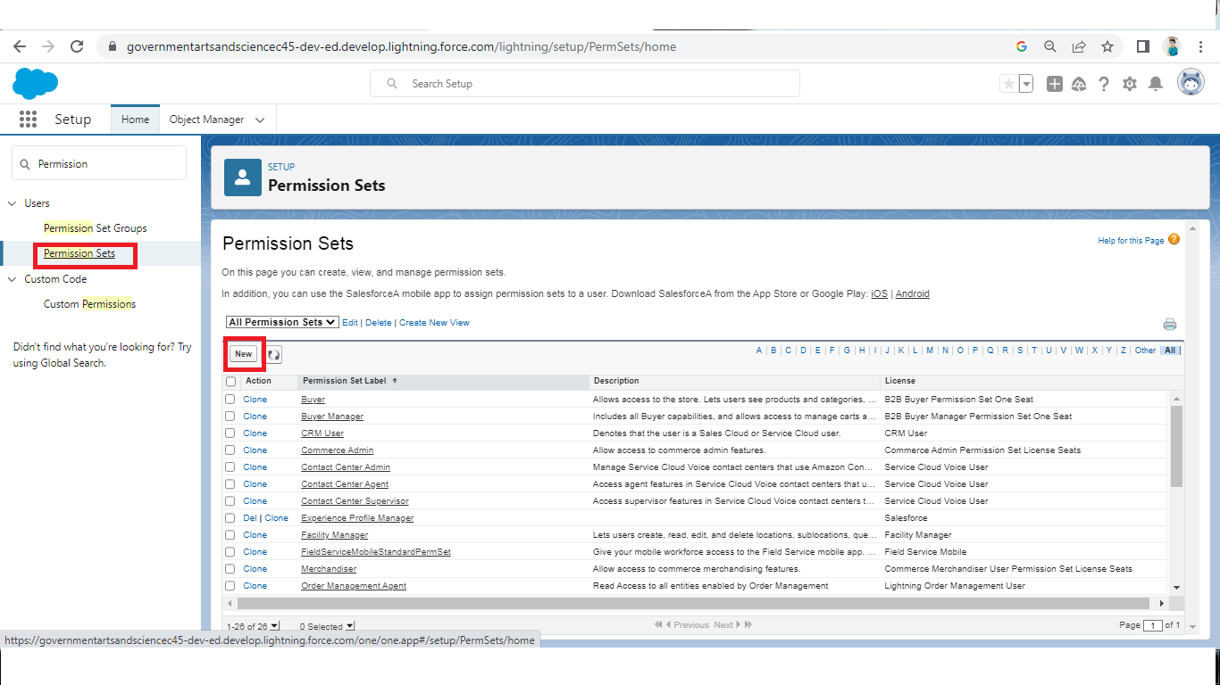

**9- Setup For OWD**

Organization-Wide Defaults, or OWDs, are the pattern security rules that you can follow for your Salesforce instance. Organization Wide Defaults are utilized to confine who can access what information in your CRM. You can award access through different methods that we will discuss later (sharing principles, Role Hierarchy, Sales Teams, and Account groups, manual sharing, and so forth).

Primarily, there are four levels of access that can be set in Salesforce OWD and they are-

● Public Read/Write/Transfer (only available of Leads and Cases)

● Public Read/Write

● Public Read/Only

● Private

**Activity1:**

Create OWD Setting

1. Setup, use the Quick Find box to find Sharing Settings.

2. Click Edit in the Organization-Wide Defaults area.

3. For each object, select the default access you want to give everyone.

4. To disable automatic access using your hierarchies, deselect Grant Access Using Hierarchies for

Saturo, Rent custom object.

5. Click Edit and from the Drop Down select private for internal and external.

6. This Setting is for all the User Which have been Created.

**Activity 2:**

**Marketing:**

1. Create the Record Level OWD Setting give it As A Private To Marketing manager And Marketing Executive.

**Sales:**

1. Sale Manager OWD is Set As Private similarly sales Rep1, Sales Rep2 same OWD for them.

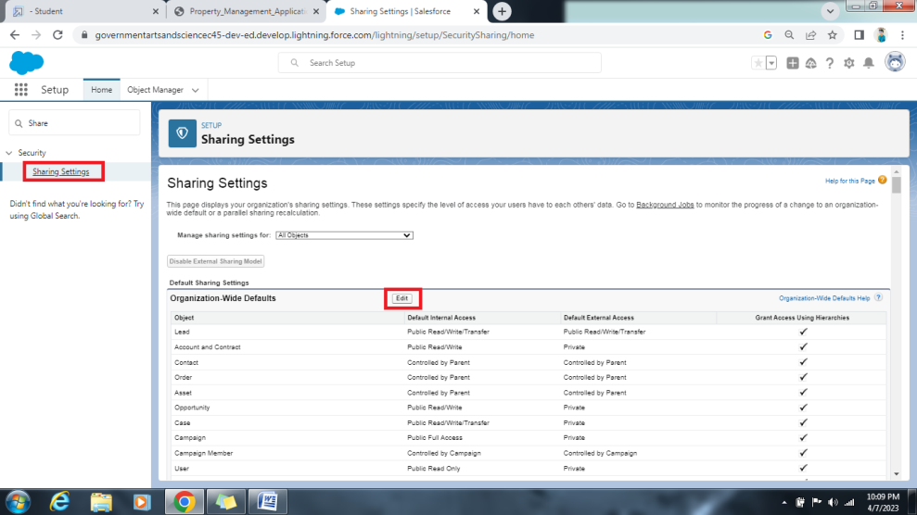

**10-Report**

Reports give you access to your Salesforce data. You can examine your Salesforce data in almost infinite combinations, display it in easy-to-understand formats, and share the resulting insights with others. Before building, reading, and sharing reports, review these reporting basics.

**Types of Reports in Salesforce**

* Tabular.
* Summary
* Matrix.
* Joined Reports.

**Activity 1:**

Create Report

1. Go to the app → click on the reports tab.
2. Click New Report.
3. Select report type from category or from report type panel or from search panel → click on start report.
4. Customize your report, then save or run it.

**Create Report for following Condition**

1. Create the Report of the Total Number of Loan Passed for for getting the Amount For the Property.

2. The Condition should be Like Loan Amount >= to 5000$.

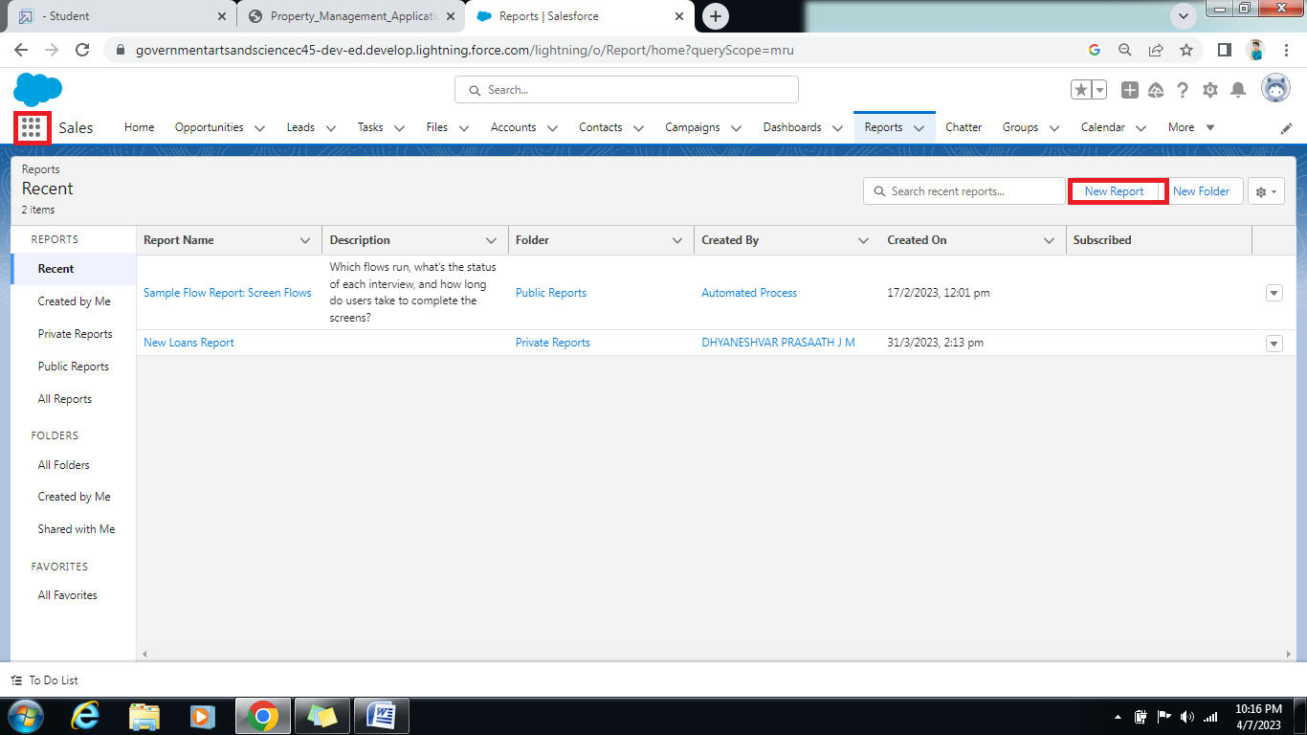

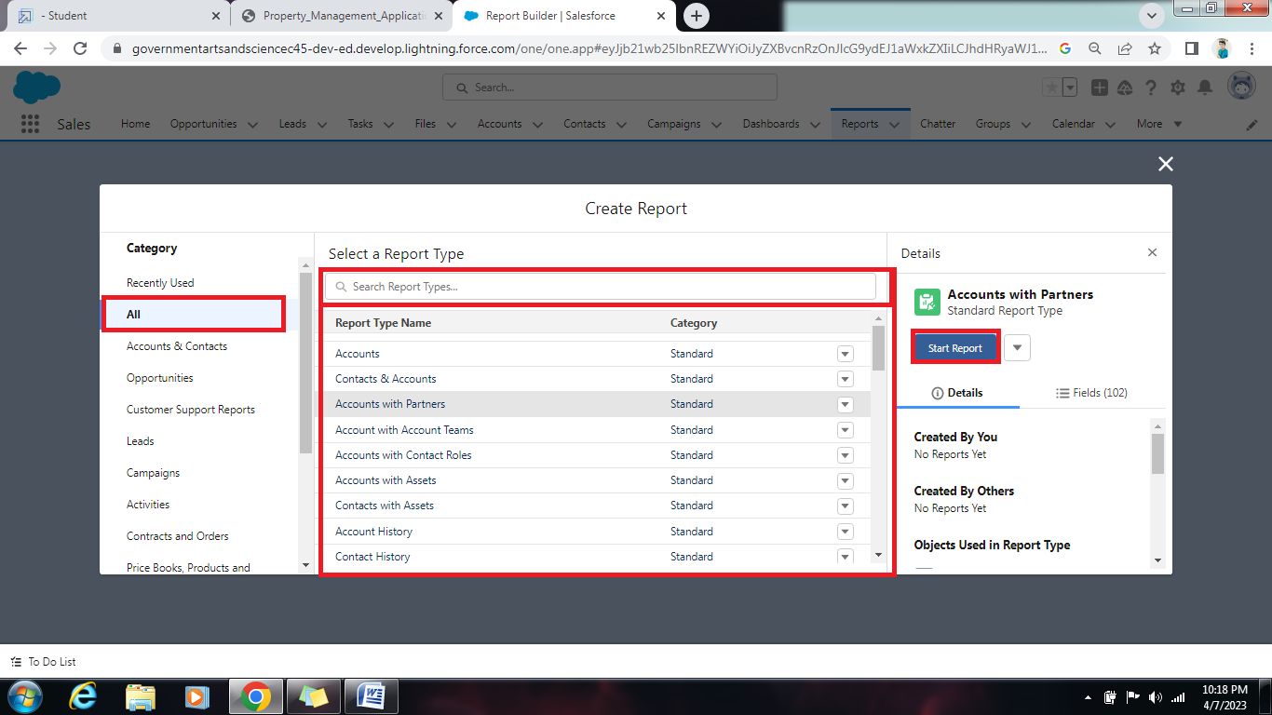

**11-Dashboards**

Dashboards help you visually understand changing business conditions so you can make decisions based on the real-time data you’ve gathered with reports. Use dashboards to help users identify trends, sort out quantities, and measure the impact of their activities. Before building, reading, and sharing dashboards, review these dashboard basics.

**Activity1:**

**Create Dashboards**

1. Go to the App Launcher and select the Dashboards

2. Select add component

3. Select the folder select the following option new lead with loan Amount

4. Select in which format you want display chart

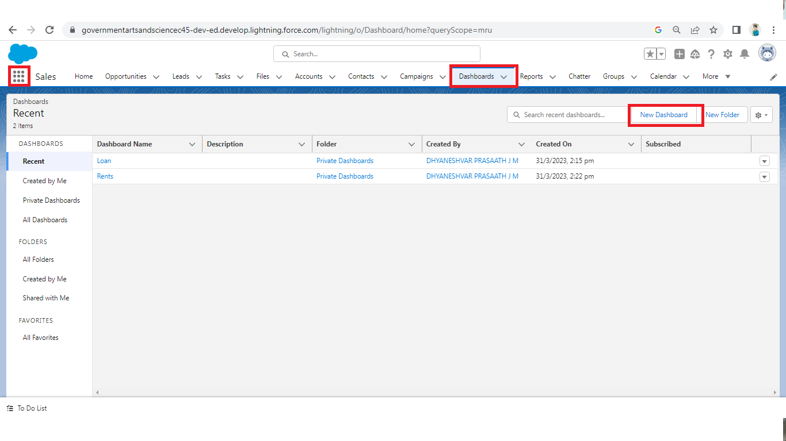

**Activity2:**

**Create Dashboard**

1. Create the Dashboard for the Same Take Any Type of Dashboard( Chart) And Display It on The App Home Page

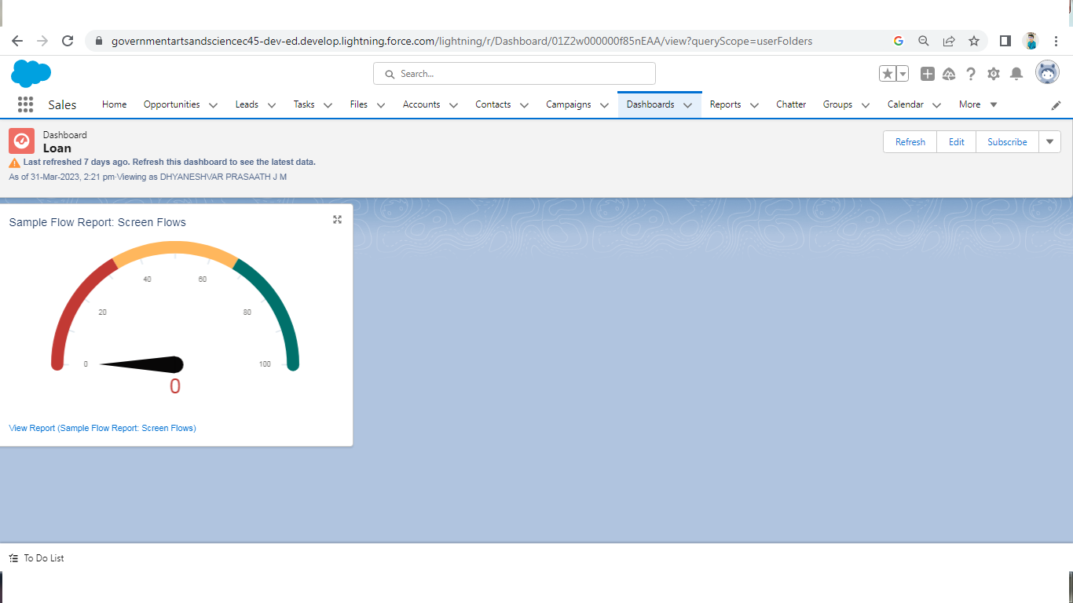

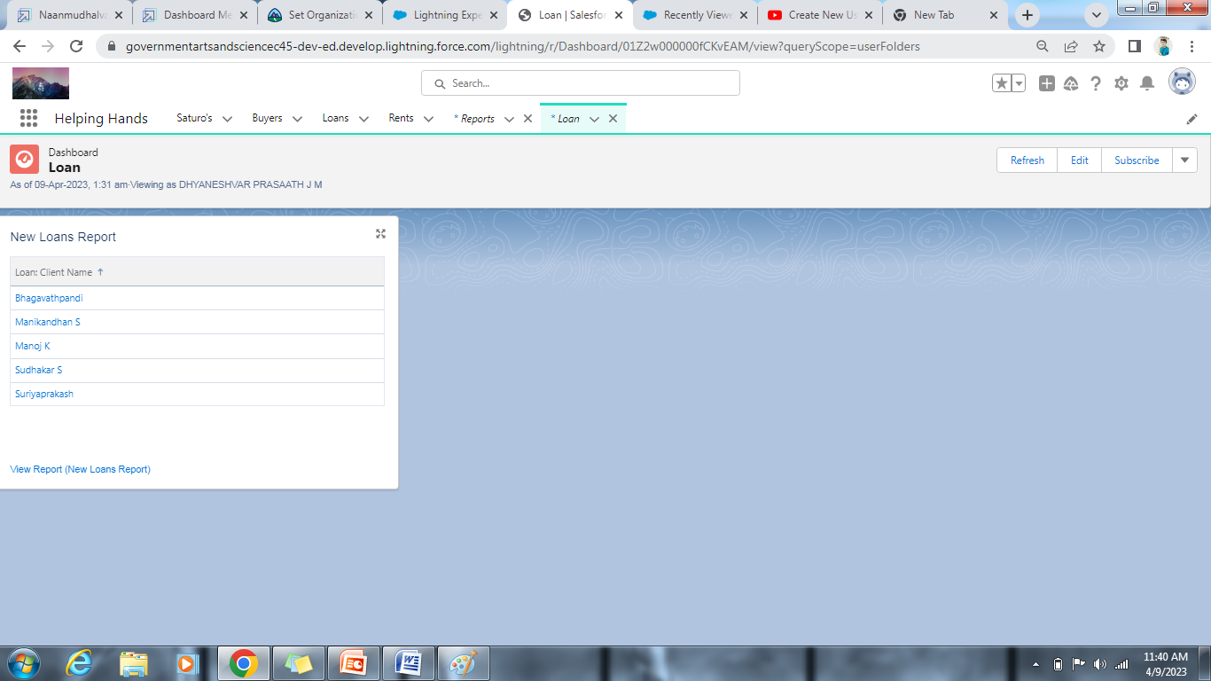

**Final Output**

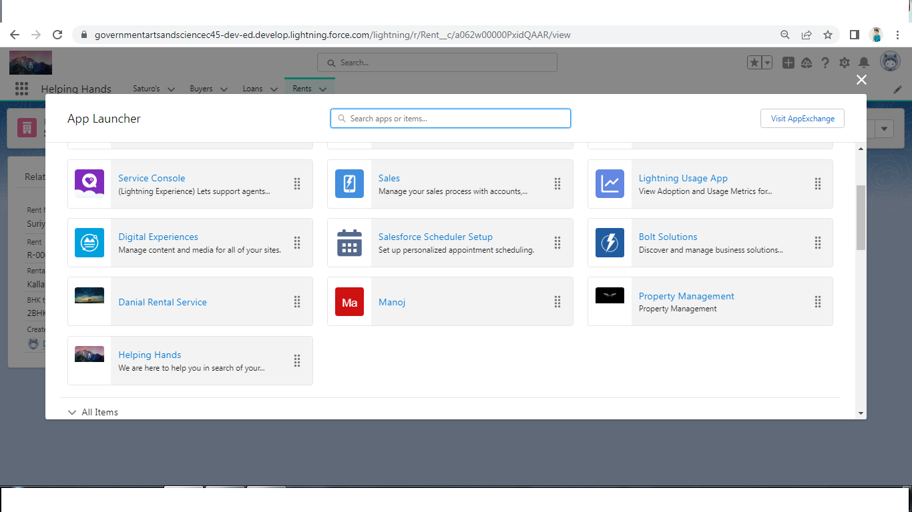

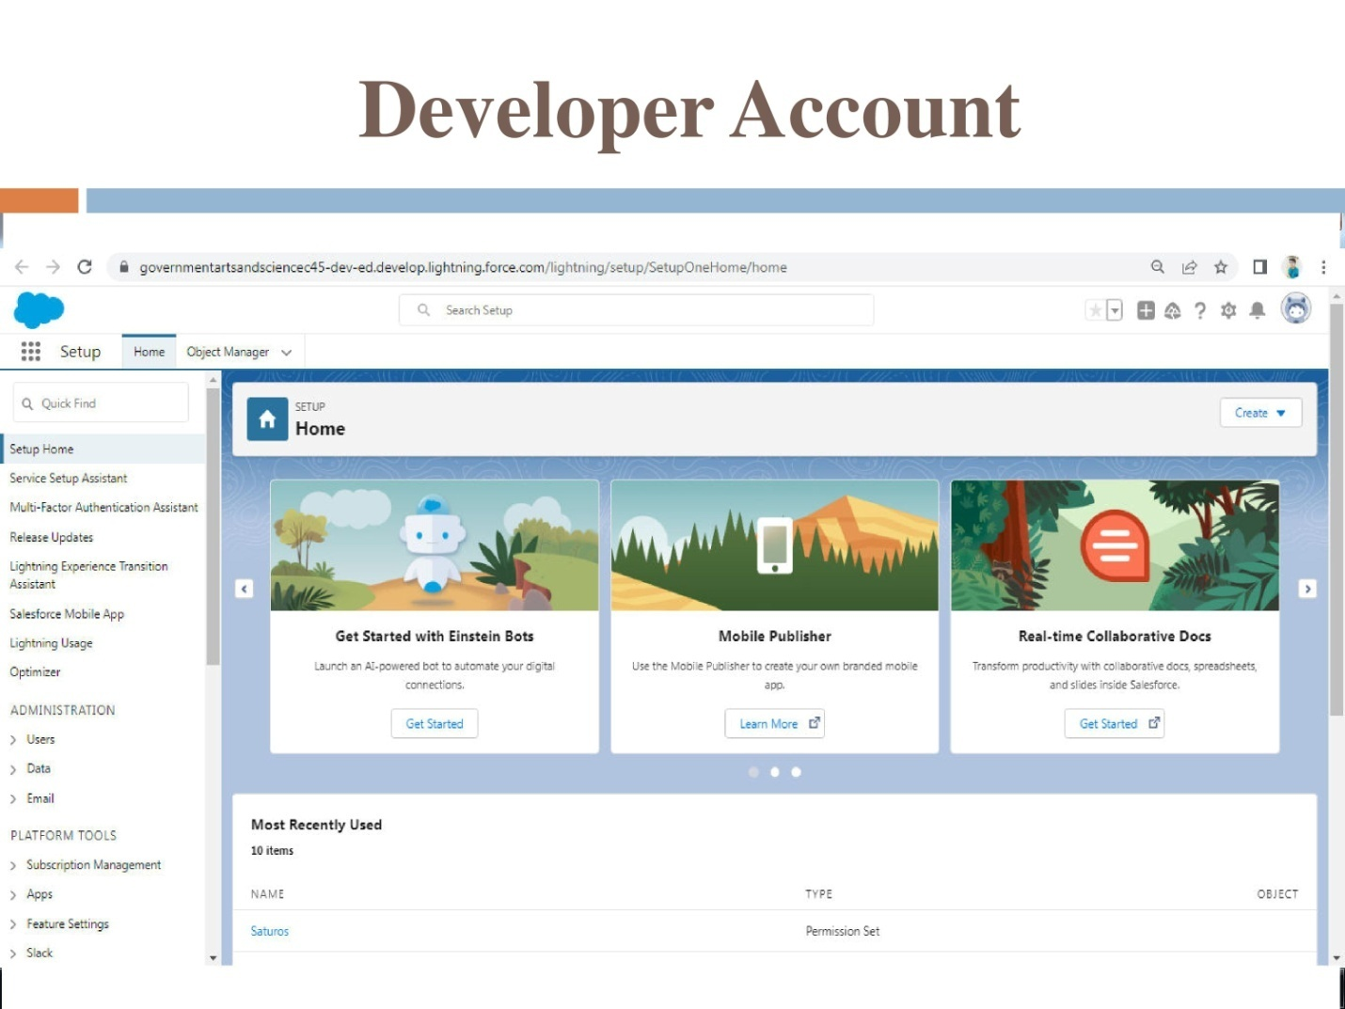

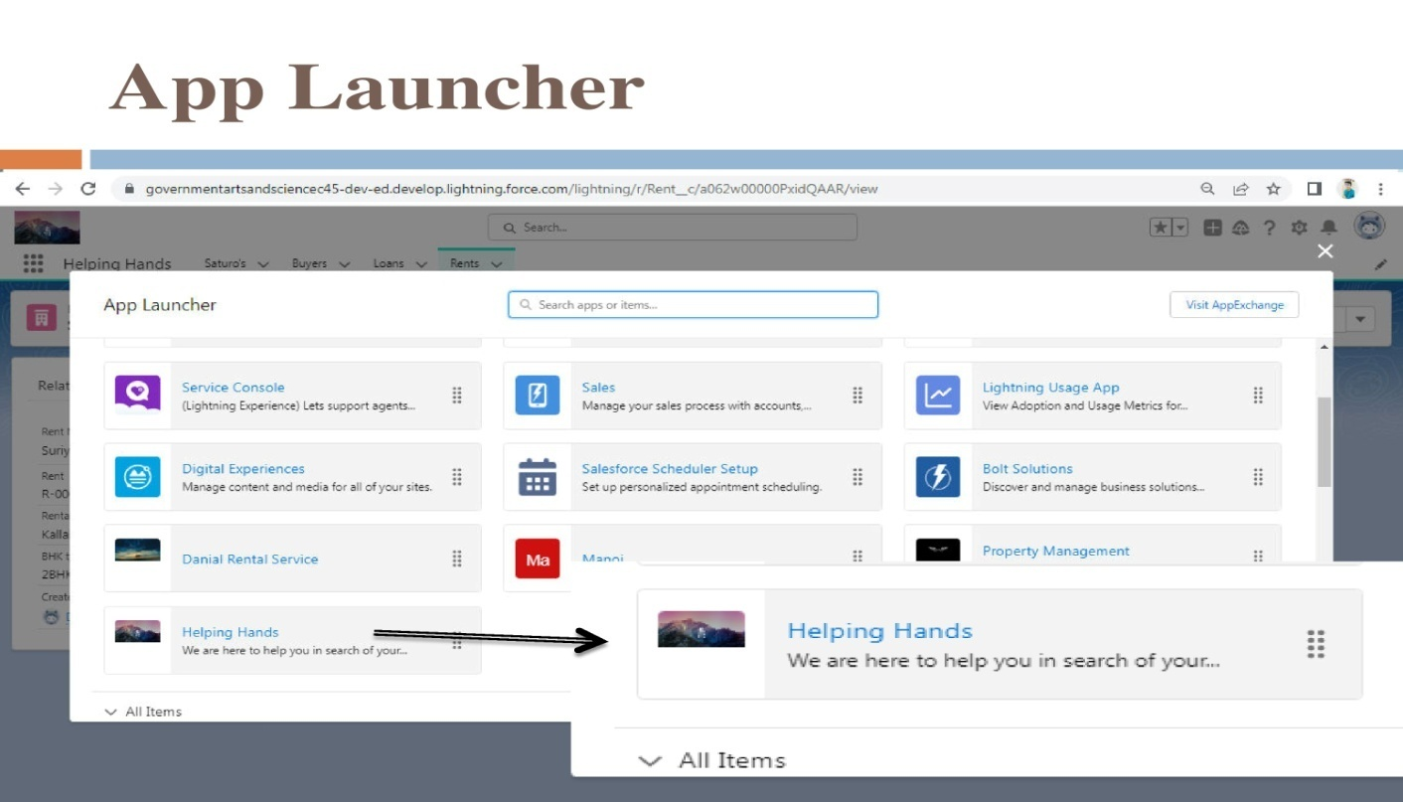

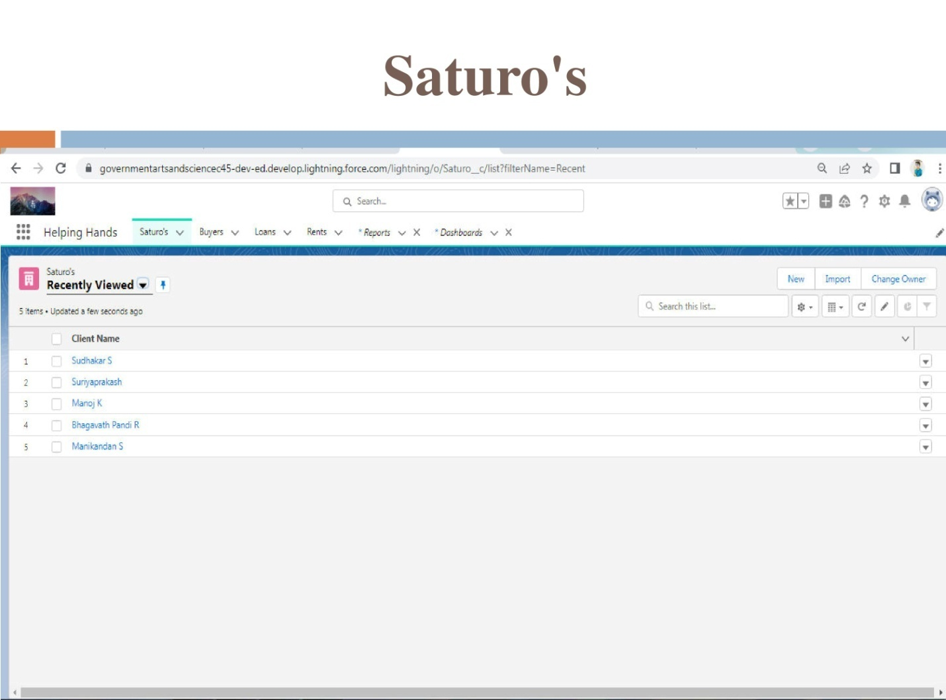

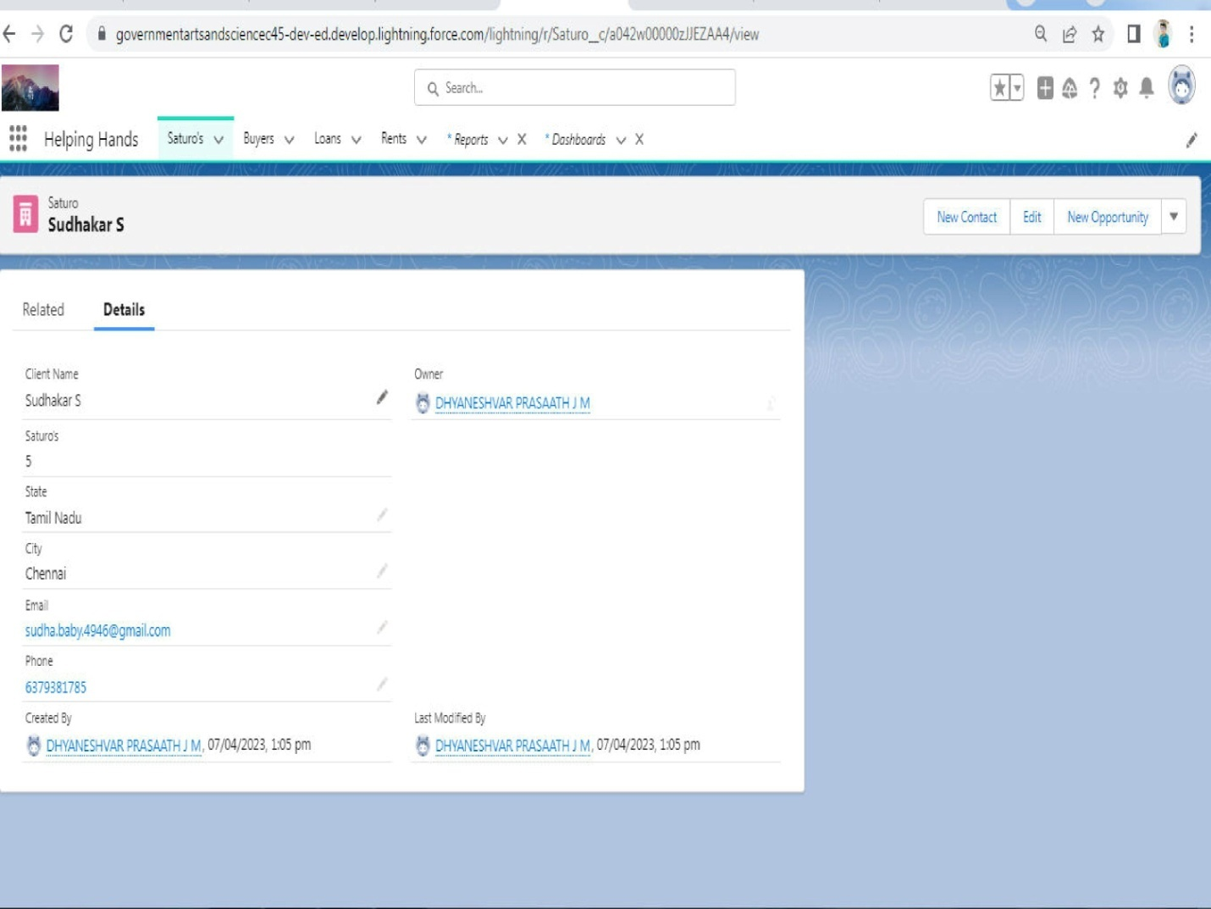

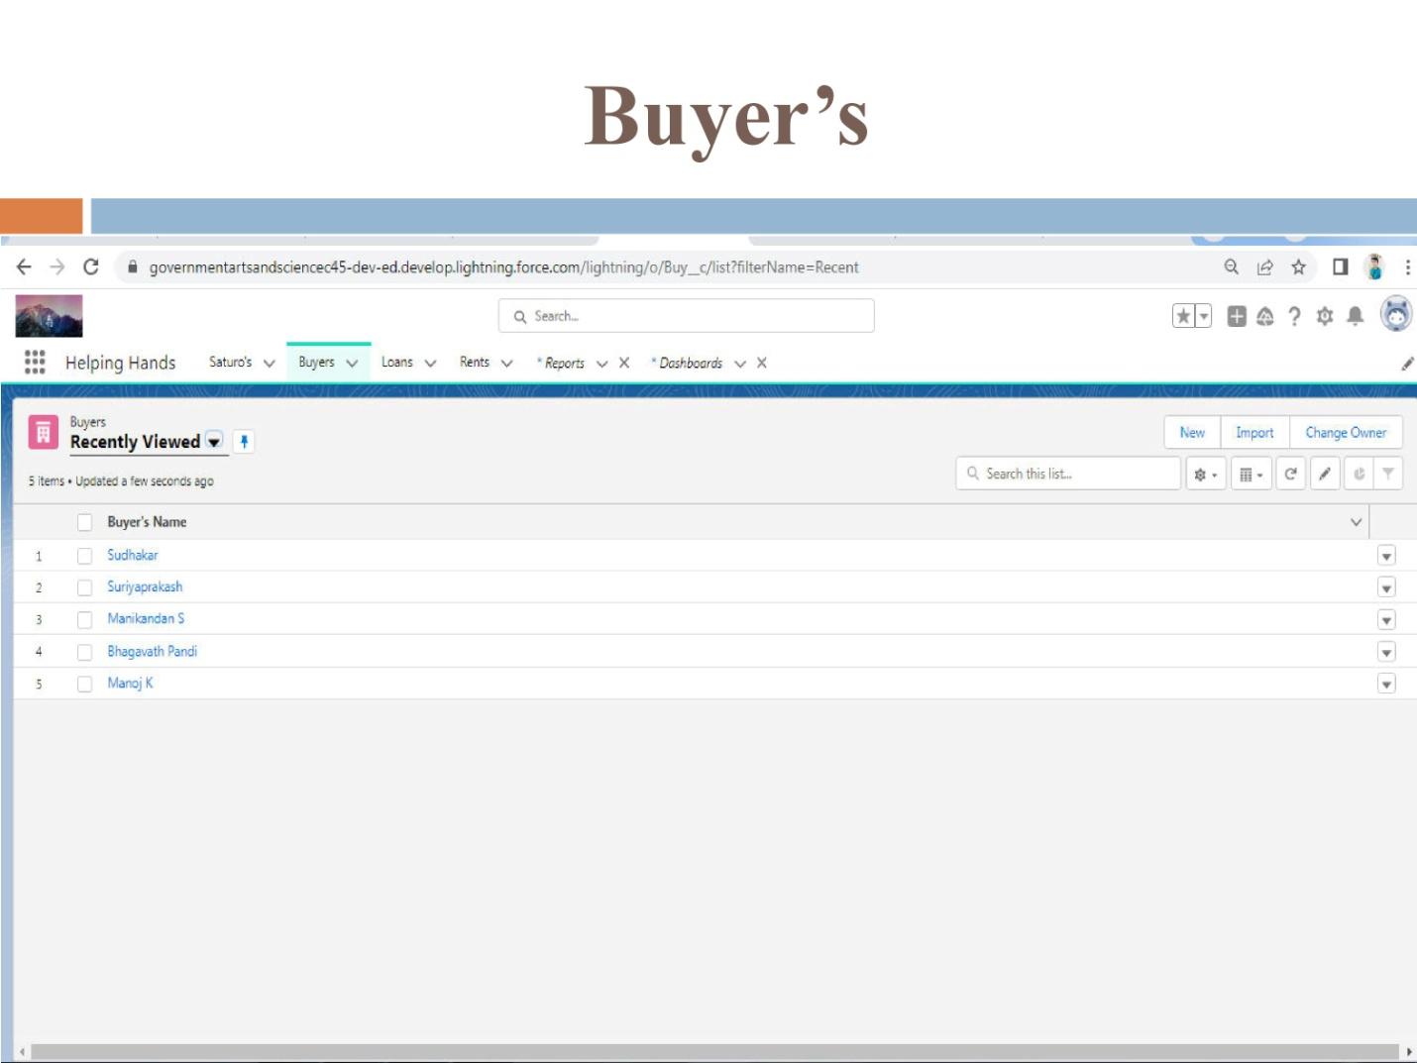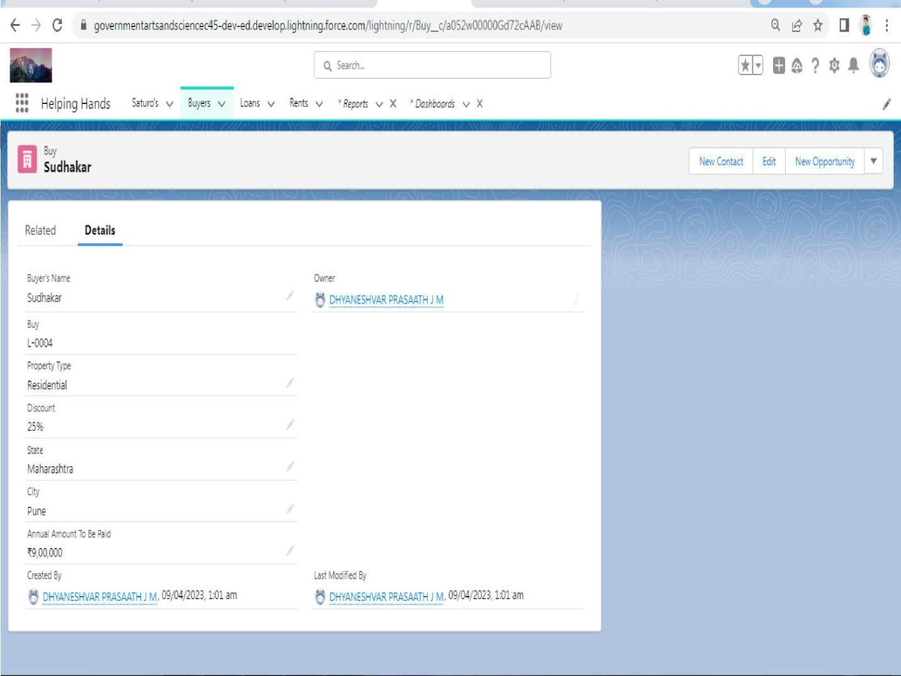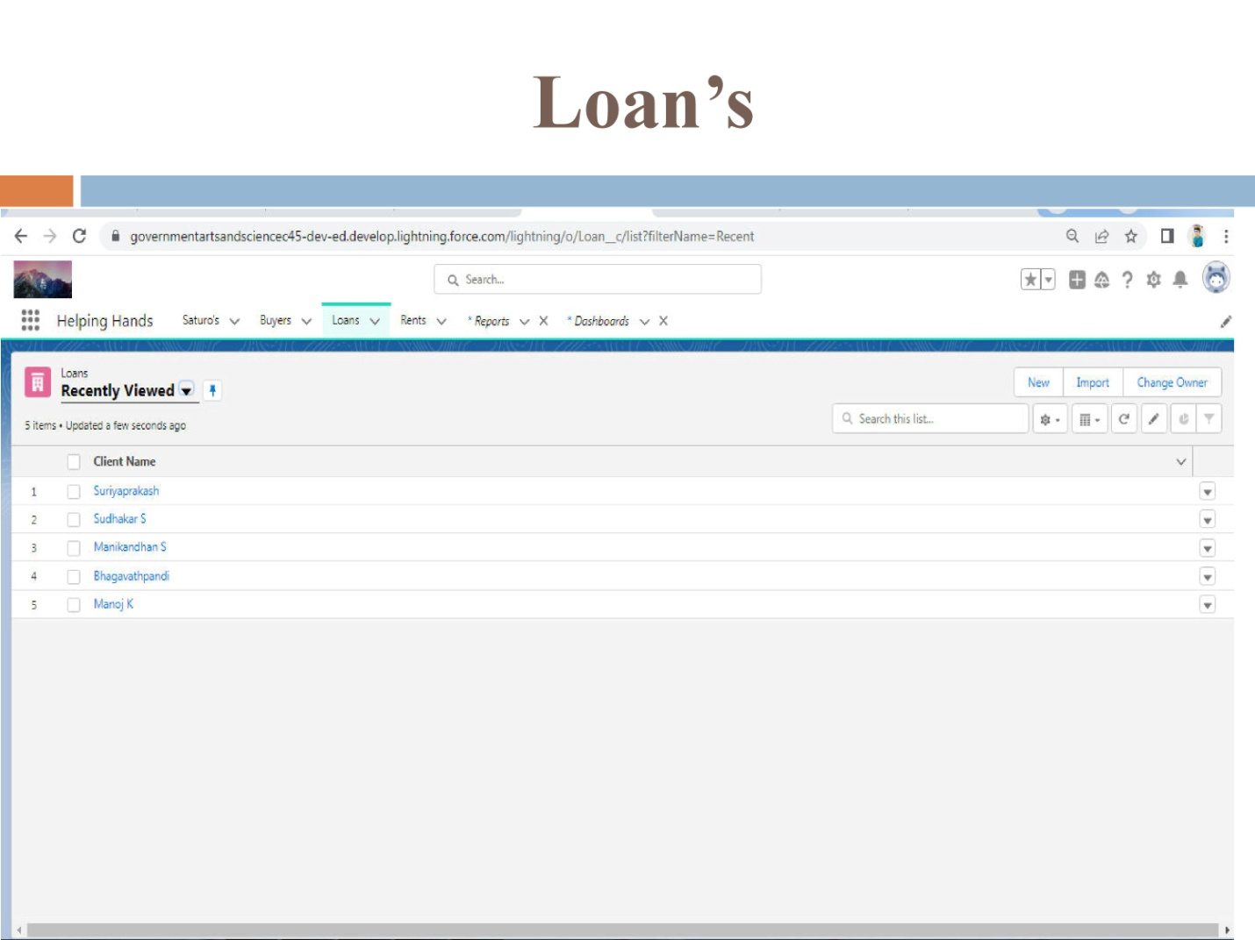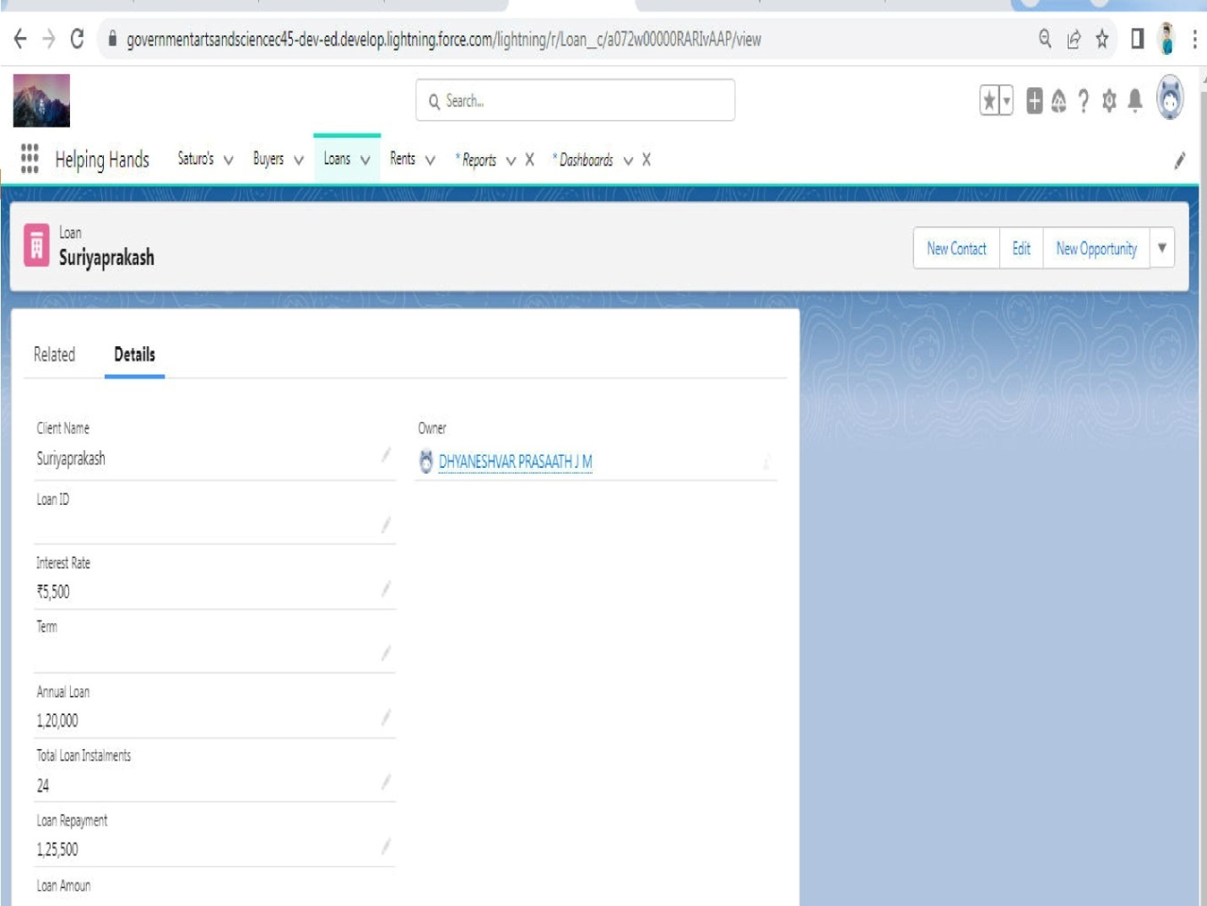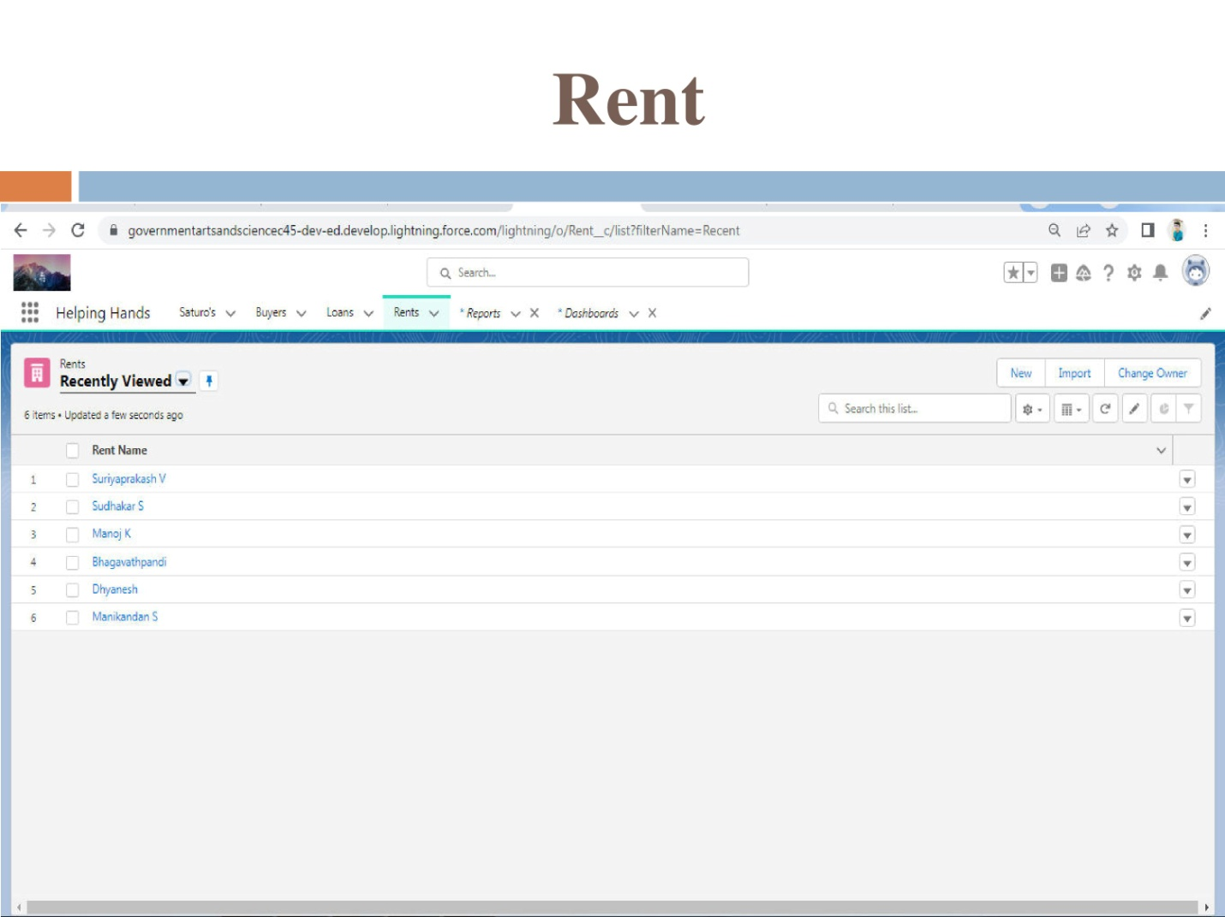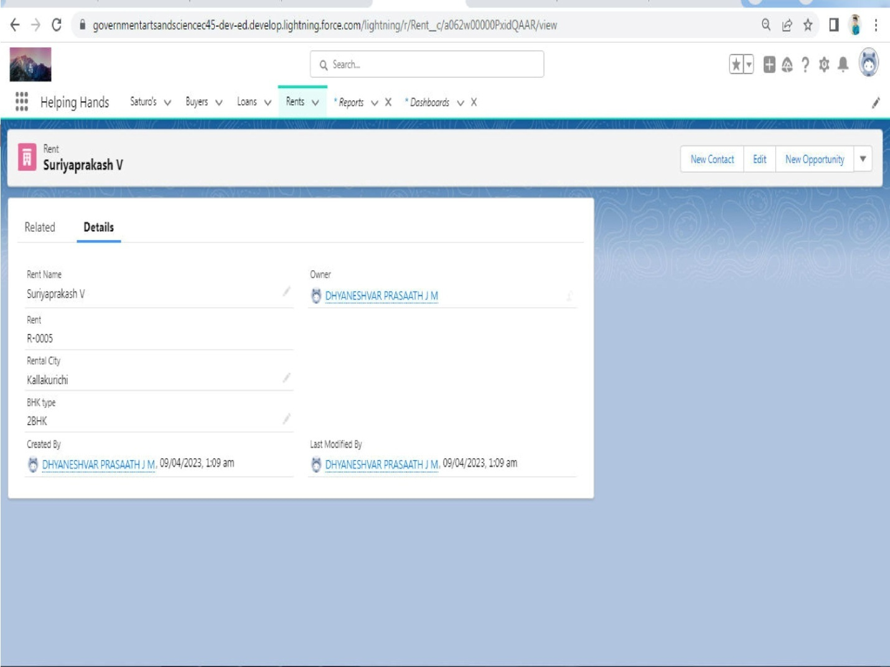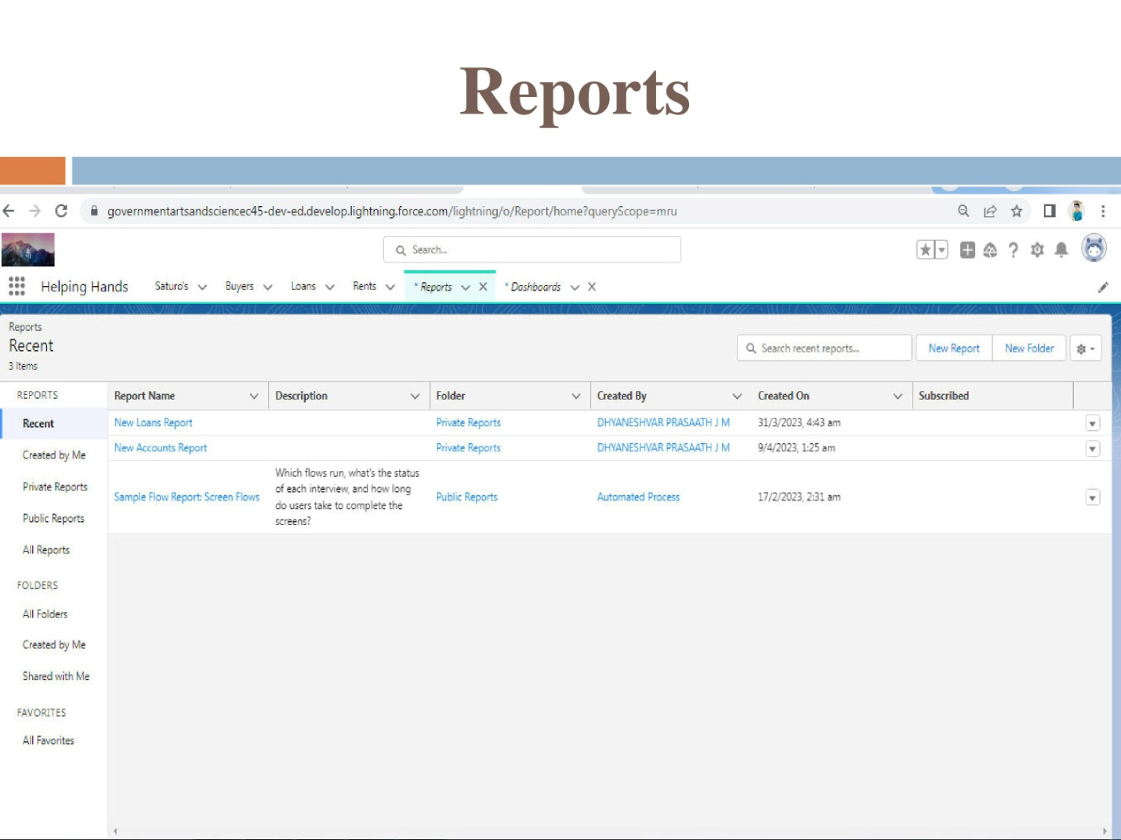

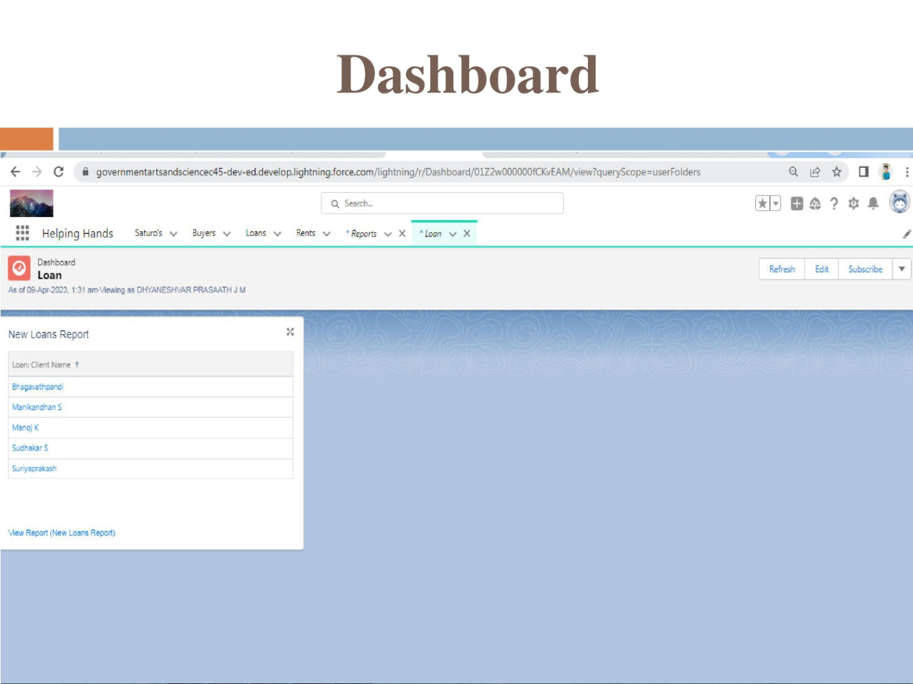

**Trailhead Profile Public URL**

Team Lead – <https://trailblazer.me/id/dhyjm>

Team Member 1 - <https://trailblazer.me/id/bhagr4>

Team Member 2 - <https://trailblazer.me/id/manis1305>

Team Member 3 - <https://trailblazer.me/id/manok38>

Team Member 4 - <https://trailblazer.me/id/sudhs44>

Team Member 5 - <https://trailblazer.me/id/suriv3>

**Advantages & Disadvantages**

Salesforce is currently the world’s #1 customer relationship management (CRM) platform, and with good reason. It’s used by thousands of businesses and organizations with a variety of goals and use cases and can be used to do everything from engaging customers with relevant digital marketing, launching ecommerce, providing great customer service, empowering teams to work efficiently from anywhere, growing businesses smarter and faster, and much more.

**Advantages**

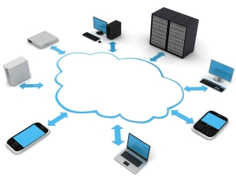

* Firstly, there is little to no risk when using Salesforce. Due to its low acquiring costs and low-risk management as an organization tool, there is very little to lose and a lot to benefit from.
* The database that Salesforce uses is also helpful in digitizing and organizing company sale records. Thus, improving the overall organization of a company.
* Salesforce and good customer service comes hand in hand.  It allows customization of profiles for individual customers as well as quick, organized access to individual records
* There is also no need to purchase software and hardware systems to help maintain and keep the application running.  Therefore, unlike most software, Salesforce requires no capital investment.
* The integrated solutions allow users to work more efficiently and increase the value of each part of the customer life cycle.  Moreover, Saleforce analytics and its reporting function gives its users the ability to expand their campaign capacity.  As a result, overall productivity can be increased and profit can be maximized.
* Since Salesforce is an application and no software is required, there is no need for constant updates as Salesforce will update automatically.

**Disadvantages**

* At times, there can be too much customization and the interface can be filled with cumbersome and tedious tools which can be seen as repetitive or distracting.
* Some users face difficulties in the transition between transactions.  Some have to go through multiple screens to process transactions.



* Salesforce has its own maintenance schedule since runs on its own cloud server.  As a result, there are times that the application will not be accessible.
* Users can also lose a personal touch as in the process of automation
* Salesforce contains barriers to adoption.  This means that even though Salesforce is cheap, the cost to integrate the application and redesigning their IT to incorporate it into a company is not the same as the cost of acquiring Salesforce. It is possible that the cost of integrating it can exceed the costs of the software itself.

**Applications**

Tenants and clients today are mobile, social, and connected, and they anticipate responsive 1:1 connections. Salesforce For Real Estate is intended for property managers, developers, and investors who look forward to automating their association with tenants and clients.

**Salesforce Property Management**, a cloud-based CRM tool helps varied real estate agents businesses in tracking different information about residential and commercial properties.

Salesforce Property Management has powerful tools to remain associated with clients and tenants continuously, support further connections, track key data about business and residential properties, including occupancy rates, essential tenants, and revenue and take your productivity, and business growth, to the next level.

**Conclusion & Future Scope**

Salesforce is a comprehensive tool with an exhausting list of benefits and, despite its seeming complexity that can overwhelm at first, can become the best friend for property managers.

Each property management company can take advantage of the platform in its unique way due to its scalability and flexibility. And even if you don’t want to spend time tuning the standard functionality of Salesforce, you can leverage its advantages with pre-configured Salesforce solutions for property management.

Once you are ready to welcome Salesforce CRM into your real estate agency and simplify the process of its implementation, then our Salesforce consulting services will be the best fit for you.

In the longer term, we expect Salesforce to integrate data science and big data capabilities to its Service Cloud and Marketing Cloud. This would result in automated customer service tasks (via Service Cloud) and would let marketers leverage data for predictive and targeted marketing (via Marketing Cloud). If this is done, it will be a step in the right direction, considering a report from MIT which stated that 71% of businesses invest in business intelligence and big data, of which 20% have said to have made substantial investments.